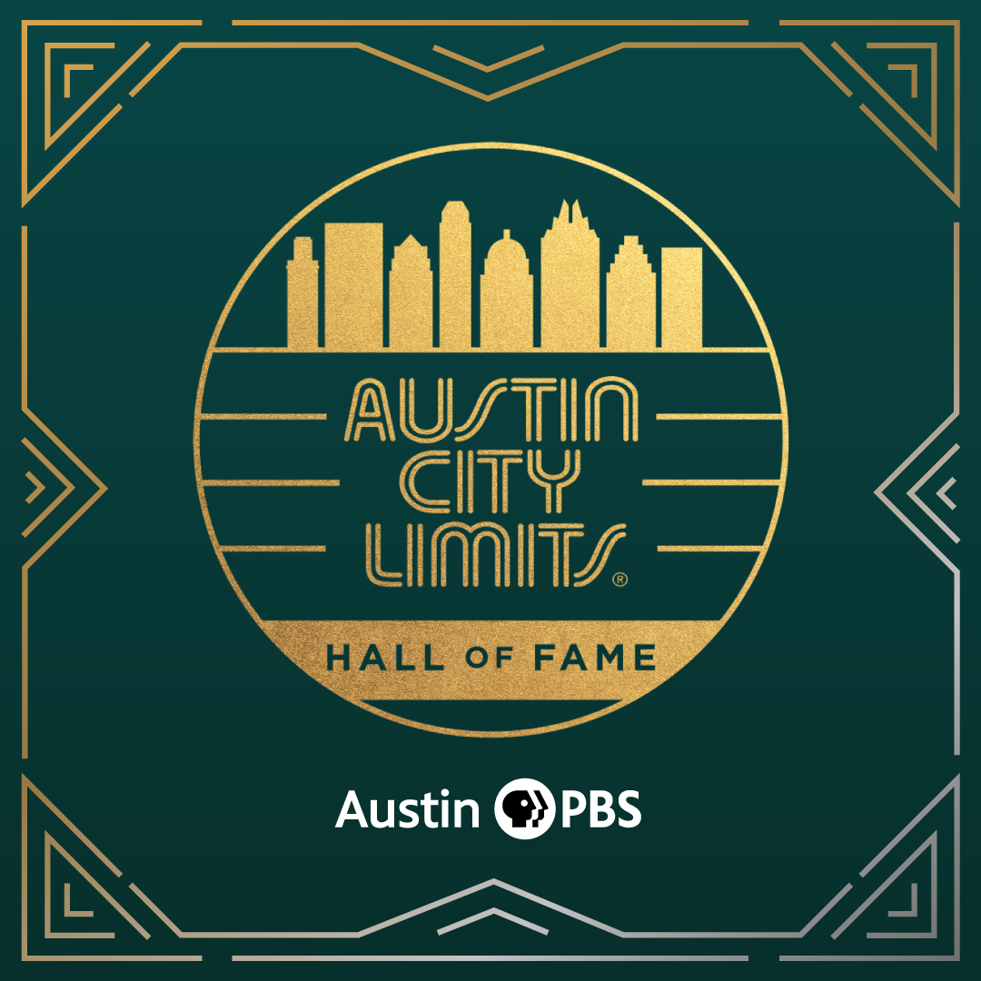

Austin City Limits 8th Annual Hall of Fame Honors Joe Ely Premieres February 25th on PBS; Stream Anytime Beginning February 26th

Special Broadcast Salutes Inductee Joe Ely with All-Star Performances featuring The Flatlanders’ Butch Hancock & Jimmie Dale Gilmore,
Rodney Crowell and Marcia Ball

Austin, TX—February 22, 2023—Iconic television series Austin City Limits (ACL) closes out Season 48 with a special installment, Austin City Limits 8th Annual Hall of Fame Honors Joe Ely, celebrating the Texas music legend and new inductee with a song-filled salute from revered Lone Star musicians and Ely’s longtime collaborators, Texas all-stars The Flatlanders, with Jimmie Dale Gilmore and Butch Hancock, alongside fellow Texans Rodney Crowell and Marcia Ball. The hour features a memorable induction by renowned Texas author Lawrence Wright along with historic highlights from the influential Ely’s eleven appearances on the ACL stage. The hour-long broadcast premieres Saturday, February 25 at 8pm ET/7pm CT on PBS. Check local PBS listings for times. The special will be available to music fans everywhere to stream online beginning Sunday, February 26 at 10am ET at pbs.org/austincitylimits. The Peabody Award-winning program, recorded live at ACL’s studio home in Austin, Texas, continues its extraordinary run as the longest-running music television show in history. ACL provides viewers a front-row seat to the best in live performance as this American music institution nears its remarkable half-century milestone. ACL airs weekly on PBS stations nationwide (check local listings) and full episodes are made available to stream online at pbs.org/austincitylimits following the initial broadcast. The show's official hashtag is #acltv.

In this special installment, ACL Hall of Fame honoree Joe Ely get his flowers in a magical, memorable salute. A trailblazing artist with longtime ties to Austin City Limits, Ely has made eleven appearances on the series beginning with his 1980 ACL debut in Season 5 and the hour features vintage ACL clips showcasing his distinctive performances across the decades. From the moment he debuted in the 1970s, Ely has mixed a rock-and-roll sensibility with hardcore honky tonkin' and become one of the most recognized and respected artists to hail from the Lone Star state. Growing up on the vast and empty plains of West Texas, his legend was forged onstage with relentlessly riveting live performances, hammered out over thousands of shows and countless touring miles from Lubbock to London and back again the long way around. Over his remarkable five-decade-plus career, he’s been at the forefront of Outlaw Country, Alt-Country, Texas Country and Americana, and has been recognized as one of the best songwriters of his generation. He has been embraced as a kindred spirit by artists as diverse as The Clash, Tom Petty and Bruce Springsteen.

Renowned author Lawrence Wright salutes Ely with a heartfelt and hilarious induction, recounting joining Ely on a trip to Lubbock, where Ely was raised and first started playing music more than 50 years ago. In response to the Texas Panhandle's flat desolation, Wright recalled, Ely told him that "I think all the emptiness made me want to fill it up." Wright fondly recalls Joe taking him to Buddy Holly’s gravesite in Lubbock where Ely had taken The Clash many decades prior to pay tribute to the legend. “The driving beat of a Joe Ely anthem tells us right away where he’s coming from,” explains Wright. “He’s a honky-tonk poet, an outlaw country minstrel, a corrido balladeer, a rocker with a broken heart, all these traditions experienced, captured, and transformed into his own distinctive style.”

The musical tribute kicks off with Austin piano legend and ACL Hall of Famer Marcia Ball taking the stage to perform Ely's song "Fingernails," a rollicking Jerry Lee Lewis-style number that Ball jokes "he wrote just for me, whether he knew it or not." The ACL house band features longtime Joe Ely Band members Lloyd Maines (pedal steel), David Grissom (guitar), Davis McLarty (drums) and Jimmy Pettit (bass) along with Chris Gage (keyboards), Bill Whitbeck (bass) and Tom Van Schaik (percussion). Country great Rodney Crowell delivers a revved-up "Cool Rockin' Loretta,” ad-libbing an entertaining testimony to Ely’s talents: “This is where I have to testify. It was Guy Clark who put me on to Joe, he said, ‘Hey man, there’s this guy from up in the Panhandle who ran away to join the circus and write songs about Indian cowboys and he can rock it all night long.’ The time has come for the man to be sworn into the Austin City Limits Hall of Fame.”

Ely steps out front for the spirited, guitar-driven classic "All Just to Get to You,” from his landmark 1995 album Letter to Laredo. For this special occasion Ely is joined by his longtime Flatlanders bandmates Jimmie Dale Gilmore and Butch Hancock for a rare trio appearance. Hancock good-naturedly recalls the time Ely “got thrown out of his own show,” before the trio trade verses on the rockin' "I Had My Hopes Up High" — the first song on Ely's very first record in 1977 and the song that kicked off his 1980 ACL debut. “Joe isn’t just a knocked out rocker,” explains Gilmore, “He’s also got this amazingly beautiful sweet side.” Hancock calls the Ely-penned gem “Because Of The Wind,” “One of the most beautiful West Texas songs you’ll ever hear,” as the trio launch into the exquisite acoustic number. Gilmore sums up the essence of Ely, saying, “There’s nobody that loves the music and loves his audience more than Joe Ely.” The finale, at Ely's request, features a Woody Guthrie song the Flatlanders have often performed, "Goin' Down the Road (Ain't Gonna Be Treated This Way).” The stars come out in the Texas sky as Crowell and Ball join in, with everybody taking a verse to bring the luminous hour to a close.

“There are Texas legends, then there is Joe Ely,” said ACL executive producer Terry Lickona. “He belongs in a class all his own. He personifies a whole era of Texas music, and there’s no more perfect candidate for the ACL Hall of Fame, considering his impact acoss the board.”

Austin City Limits 8th Annual Hall of Fame Honors Joe Ely setlist:
Marcia Ball “Fingernails”
Rodney Crowell “Cool Rockin’ Loretta”
Joe Ely “All Just To Get To You”
Joe Ely, Butch Hancock, Jimmie Dale Gilmore “I Had My Hopes Up High”
Joe Ely, Butch Hancock, Jimmie Dale Gilmore “Because Of the Wind”
Joe Ely & All-Star Finale “Goin Down That Old Dusty Road”

Fellow newly-minted Hall of Fame inductee Sheryl Crow was celebrated with a companion Hall of Fame tribute that kicked off the second half of ACL’s Season 48 in January 2023 and featured music greats Brandi Carlile, Jason Isbell, Brittney Spencer and Lucius’ Jess Wolfe saluting the Grammy Award-winning artist. Season 48 premiered in October 2022 with a historic line-up spotlighting an unprecedented number of female artists, including a sterling season opener featuring singer-songwriter Brandi Carlile, who recently earned a trio of 2023 Grammys. Season 48 also showcased many highly-praised acts who topped 2022 Year-End Best Lists, including electronic duo Sylvan Esso, Americana singer-songwriter Allison Russell and indie pop duo Lucius. Other highlights were ACL debuts from breakout artists including Japanese Breakfast, Arlo Parks and Cuban funk sensations Cimafunk and The Tribe along with deep-dive hours spotlighting acclaimed rock act The War on Drugs, country superstar Maren Morris and legendary alternative rock pioneers Pavement. The first tapings of ACL’s Season 49 have been announced and include acclaimed singer-songwriter Margo Price and indie-pop band MUNA.

For images and episode information, visit Austin City Limits press room at http://acltv.com/press-room/.

Established in 2014, the Austin City Limits Hall of Fame celebrates the legacy of legendary artists and key individuals who have played a vital part in the pioneering music series remarkable nearly half-century as a music institution. The Hall of Fame has inducted over twenty artists at seven previous ceremonies including Willie Nelson, Stevie Ray Vaughan & Double Trouble, Lloyd Maines, Asleep at the Wheel, Loretta Lynn, Guy Clark, Flaco Jiménez, Townes Van Zandt, Kris Kristofferson, Bonnie Raitt, B.B. King, Roy Orbison, Rosanne Cash, The Neville Brothers, Ray Charles, Marcia Ball, Los Lobos, Lyle Lovett, Buddy Guy, Shawn Colvin. The seventh annual Hall of Fame in 2021 welcomed Lucinda Williams, Wilco and Alejandro Escovedo to its ranks.

Watch live on PBS, or stream anytime on PBS.org. Viewers can visit acltv.com for news regarding upcoming Season 49 tapings, live streams and episode schedules or by following ACL on Facebook, Twitter and IG. Fans can also browse the ACL YouTube channel for exclusive songs, behind-the-scenes videos and full-length artist interviews.

Austin City Limits
Austin City Limits (ACL) offers viewers unparalleled access to featured acts in an intimate setting that provides a platform for artists to deliver inspired, memorable, full-length performances. Now in its 48th Season, the program is taped live before a concert audience from The Moody Theater in downtown Austin. Austin City Limits is the longest-running music series in television history and remains the only TV series to ever be awarded the National Medal of Arts. Since its inception, the groundbreaking music series has become an institution that's helped secure Austin's reputation as the Live Music Capital of the World. The historic Austin PBS Studio 6A, home to 36 years of ACL concerts, has been designated an official Rock & Roll Hall of Fame Landmark. In 2011, ACL moved to the new venue ACL Live at The Moody Theater in downtown Austin. ACL received a rare institutional Peabody Award for excellence and outstanding achievement in 2012.

Austin City Limits is produced by Austin PBS and funding is provided in part by Dell Technologies, Workrise, the Austin Convention Center Department, Cirrus Logic and AXS Ticketing. Additional funding is provided by the Friends of Austin City Limits. Learn more about Austin City Limits, programming and history at acltv.com.

Austin City Limits Hall of Fame
In 2014, Austin PBS, KLRU-TV — creator and producer of the legendary PBS show Austin City Limits — established the Austin City Limits Hall of Fame to recognize legendary musicians and key individuals who have been instrumental in making television’s longest-running popular music show an institution. Each year a new class of honorees are inducted and celebrated at a live event taped to air on PBS. It is also a historical archive, educational resource and celebration of Austin City Limits —telling the story of the show through photos, a timeline/anthology mural and in the near future, an interactive database of vintage Austin City Limits performances and video footage of interviews, behind-the-scenes and never before seen performances throughout the decades. Honorees to-date include Willie Nelson, Stevie Ray Vaughan & Double Trouble, Lloyd Maines, Asleep at the Wheel, Loretta Lynn, Flaco Jiménez, Guy Clark, Townes Van Zandt, Bonnie Raitt, Kris Kristofferson, B.B. King, Rosanne Cash, The Neville Brothers, Roy Orbison, Marcia Ball, Ray Charles, Los Lobos, Lyle Lovett, Shawn Colvin, Buddy Guy, Lucinda Williams, Wilco, Alejandro Escovedo, Joe Ely and Sheryl Crow.

Austin City Limits 8th Annual Hall of Fame is produced by Austin PBS and funding is provided in part by AXS Ticketing, American Honda Motor Company, Netspend Corporation and YETI.

Media Contact:

Maureen Coakley for ACL
maureen@coakleypress.com
t: 917.601.1229

