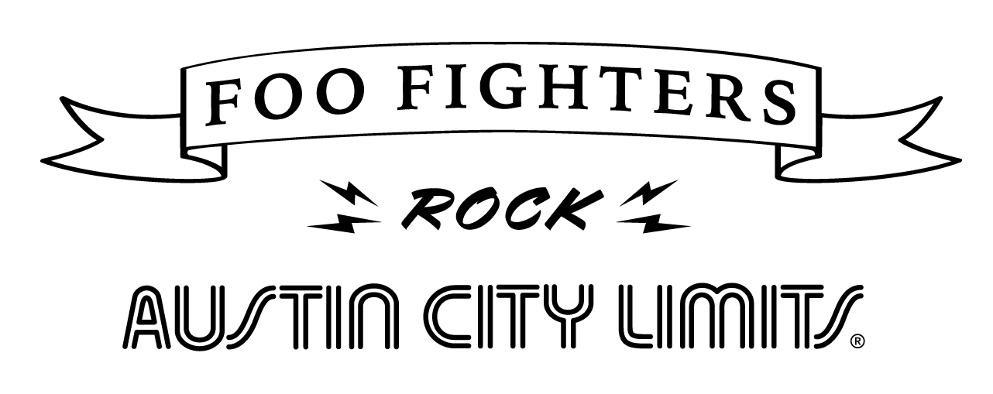

ACL Celebrates Foo Fighters’ 25th Anniversary with Epic Hour Premiering January 9 on PBS

Available to Stream at pbs.org/austincitylimits Beginning January 10

Austin, TX—January 6, 2021—Live music beacon Austin City Limits (ACL) resumes Season 46 with an electrifying hour: Foo Fighters Rock Austin City Limits, celebrating the 25th Anniversary of the rock superstars (and anticipating their upcoming album, Medicine At Midnight, due February 5th). Experience the communal magic of live music with the best, the best, the best of Foo Fighters, featuring a hit parade of classics from the powerhouse band’s two unforgettable ACL appearances, originally broadcast in 2009 and 2015. The must-see hour premieres Saturday, January 9 at 8pm CT/9pm ET, as ACL’s Season 46 returns with six installments. The episode will be available to music fans everywhere to stream online beginning Sunday, January 10 @10am ET at pbs.org/austincitylimits. With live music on hold, ACL continues to provide viewers a front-row seat to the best in live performance. The program airs weekly on PBS stations nationwide (check local listings for times) and full episodes are made available online for a limited time at pbs.org/austincitylimits immediately following the initial broadcast. Viewers can visit acltv.com for news regarding future tapings, episode schedules and select live stream updates. The show's official hashtag is #acltv.

Get ready for an hourlong rock ‘n’ roll masterclass while we countdown to the rapidly approaching release of Foo Fighters’ 10th album Medicine at Midnight, as Austin City Limits celebrates the band with a silver anniversary salute. The twelve-time GRAMMY-winners took breaks from selling out arenas and stadiums across the globe for ACL sets in Season 34 and 40, making ACL history with two typically superstar-caliber performances. The electrifying hour showcases highlights from Foo Fighters 2009 debut in ACL’s original Studio 6A and 2015 return as Dave Grohl, Taylor Hawkins, Nate Mendel, Chris Shiflett, Pat Smear and Rami Jaffee serve up blistering and intimate renditions of FF anthems including “My Hero,” “Everlong,” “All My Life” and “Best of You.” Throughout the hour, Foo Fighters transform the two historic ACL studios into a stadium-caliber yet intimate communion as the pumped-up crowds thrill to an epic blitz of pure rock bliss in not one, but two performances for the ages.

“I’m sure I can speak for every musician when I say that being asked to come play Austin City Limits is practically like getting a medal,” says Dave Grohl. “As a musician it’s something to aspire to and if you actually achieve that then you wear it like a badge.”

Foo Fighters Rock Austin City Limits setlist:
All My Life (2009)
My Hero (2009)
Everlong (2009)
Monkey Wrench (2009)
The Pretender (2009)
Times Like These (2015)
Rope (2015)
Walk (2015)
Best of You (2015)

Season 46 Broadcast Schedule:
January 9 Foo Fighters Rock Austin City Limits
January 16 The War And Treaty | Ruthie Foster
January 23 Ray Wylie Hubbard
January 30 The Best of Spoon
February 6 Texas Icons: Jerry Jeff Walker & Billy Joe Shaver
February 13 Allen Toussaint: New Orleans Legend

ACL’s Season 46 premiered in October with standout performances from 2021 Grammy nominee Rufus Wainwright, UK country-soul sensation Yola, rock and country trailblazers The Mavericks, acclaimed Austin standout Jackie Venson, salutes to late ACL legends John Prine and Stevie Ray Vaughan, a celebration of 50 years of Asleep at the Wheel and more.

Tune-in, log on, and let ACL be a trusted sidekick for entertainment during these challenging days. Viewers can visit acltv.com for news regarding live streams, future tapings and episode schedules or by following ACL on Facebook, Twitter, IG and TikTok. Fans can also browse the ACL YouTube channel for exclusive songs, behind-the-scenes videos and full-length artist interviews.

For images and episode information, visit Austin City Limits press room at http://acltv.com/press-room/.

About Austin City Limits
Austin City Limits (ACL) offers viewers unparalleled access to featured acts in an intimate setting that provides a platform for artists to deliver inspired, memorable, full-length performances. Now in its 46th Season, the program is taped live before a concert audience from The Moody Theater in downtown Austin. Austin City Limits is the longest-running music series in television history and remains the only TV series to ever be awarded the National Medal of Arts. Since its inception, the groundbreaking music series has become an institution that’s helped secure Austin’s reputation as the Live Music Capital of the World. The historic KLRU Studio 6A, home to 36 years of ACL concerts, has been designated an official Rock & Roll Hall of Fame Landmark. In 2011, ACL moved to the new venue ACL Live at The Moody Theater in downtown Austin. ACL received a rare institutional Peabody Award for excellence and outstanding achievement in 2012.
Austin City Limits is produced by Austin PBS, KLRU-TV and funding is provided in part by Dell Technologies, RigUp, the Austin Convention Center Department and Cirrus Logic. Additional funding is provided by the Friends of Austin City Limits. Learn more about Austin City Limits, programming and history at acltv.com.

Media Contact:

Maureen Coakley for ACL
maureen@coakleypress.com
t: 917.601.1229

