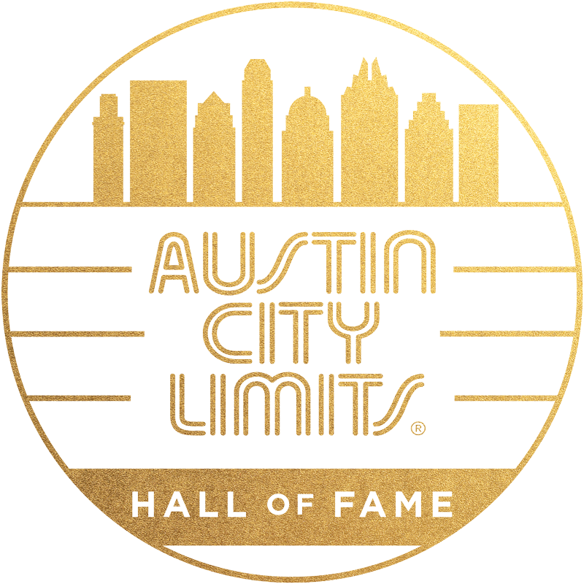

Austin City Limits Hall of Fame: The First 6 Years

Premieres January 2 on PBS; Performances featuring Inductees Willie Nelson, Buddy Guy, Bonnie Raitt, Kris Kristofferson, Shawn Colvin, Rosanne Cash & Los Lobos and Guest Performers Gary Clark Jr., Jason Isbell, Mavis Staples, Lyle Lovett, Brandi Carlile, Sarah Jarosz, Jimmie Vaughan, Emmylou Harris, Elvis Costello, Chris Isaak, Raul Malo, Patty Loveless, Taj Mahal, Neko Case & more

Austin, TX—December 16, 2020—Kick off the New Year with a good ‘un: Austin City Limits presents ACL Hall of Fame: The First 6 Years, a special broadcast featuring a victory lap of some of the finest performances from the first six years of the annual ACL Hall of Fame induction ceremonies, from the inaugural induction celebration in 2014 to 2019’s sixth annual ceremony. The Austin City Limits Hall of Fame was established in 2014 to honor beacons of American music who have played an instrumental role in making the iconic music series a music institution. The 14-song, all-star salute, recorded live in Austin, Texas, features best-in-class performances and collaborations, many never-before-broadcast, from the annual celebrations in a performance-packed hour with Hall of Fame honorees including Willie Nelson, Buddy Guy, Los Lobos, Bonnie Raitt, Rosanne Cash and Kris Kristofferson performing alongside special guests. ACL Hall of Fame: The First 6 Years premieres Saturday, January 2 at 8pm CT/9pm ET. Check local PBS listings for times. The special will be available to music fans everywhere to stream online beginning Sunday, January 3 @10am ET at pbs.org/austincitylimits. With live music still on hold, ACL continues to provide viewers a front-row seat to the best in live performance. The series returns January 9 ringing in the new year with all-new episodes as part of its Season 46.

The Hall of Fame celebration captures one-of-a-kind performances and emotional moments as the hour opens with the very first inductee into ACL’s inaugural Hall of Fame in 2014: Willie Nelson, who appeared on ACL’s pilot episode in 1974, and performs his classic “On the Road Again” joined by special guests Emmylou Harris and Lyle Lovett. Blues giant Buddy Guy, a 2019 inductee, performs an electrifying take on his gem “Damn Right, I’ve Got the Blues” joined by a longtime friend, bluesman Jimmie Vaughan. For her induction in 2017, Rosanne Cash shares the stage with friends Elvis Costello and Neko Case, trading verses on her early chart-topping anthem “Seven Year Ache,” joined by legendary guitarist Ry Cooder. A trio of music’s most expressive vocalists, Chris Isaak, Brandi Carlile and Raul Malo, join forces to celebrate the legendary Roy Orbison’s 2017 induction with a joyous rendition of the pioneering rocker’s signature “Oh, Pretty Woman.” Acclaimed singer-songwriter Jason Isbell performs a moving solo rendition of Texas singer-songwriter Guy Clark’s classic, “Desperados Waiting For A Train,” saluting the 2015 inductee. Bonnie Raitt celebrates her induction in 2016 teaming up with handpicked guests Mavis Staples and Taj Mahal on a blazing rendition of her smash “Thing Called Love.” Kris Kristofferson, a fellow 2016 inductee, lights up the stage with a moving, solo acoustic performance of his early 70s classic “Lovin’ Her Was Easier.” Celebrating her induction in 2019, Shawn Colvin delivers a captivating performance of her early gem “Diamond In The Rough,” from her 1989 debut Steady On, joined by a pair of Texas singer-songwriters, Sarah Jarosz and fellow inductee Lyle Lovett. The queen of country music, Loretta Lynn, who first appeared on the series in 1983, is celebrated during her 2015 induction by country singer Patty Loveless, with a stirring rendition of the living legend’s first number one country hit “Don’t Come Home A-Drinkin’”.

The “first family of funk,” The Neville Brothers, the first New Orleans act to appear on ACL in 1979, are saluted by Trombone Shorty and members of the next-generation Nevilles Band for a scorching NOLA-style tribute to the influential funk ‘n’ soul collective in honor of their 2017 induction. Legendary Texas singer-songwriter Townes Van Zandt is inducted in 2015 with an all-star tribute of his “White Freightliner Blues” with music greats Lyle Lovett, Ray Benson, Vince Gill, Gillian Welch, Dwight Yoakam and more trading verses on the classic. Blues-rock star Gary Clark Jr. puts down his guitar for the occasion and steps up to the mic to pay vocal tribute to 2018 inductee Ray Charles, delivering a radiant “Night Time Is the Right Time” while vocalists Ruthie Foster, Carolyn Wonderland and Shelley King do The Raelettes proud with show-stopping backing chorus. American originals Los Lobos join the fifth class of inductees in 2018 performing a classic from their celebrated four-decade plus career, “La Pistola Y El Corazon”. The broadcast comes to an epic close saluting blues-rock icon Stevie Ray Vaughan’s 2014 induction into the first class of inductees, as a murderers’ row of guitar greats, including Willie Nelson, Buddy Guy and Johnny Lang, perform a blistering “Texas Flood,” the Lone Star classic Vaughan made famous when he performed it on his now-classic 1983 ACL debut, in a performance for the ages.

Austin City Limits Hall of Fame: The First Six Years setlist:
Willie Nelson w/ Emmylou Harris, Lyle Lovett “On the Road Again”
Buddy Guy w/Jimmie Vaughan “Damn Right, I’ve Got the Blues”
Rosanne Cash w/Elvis Costello, Neko Case, Ry Cooder “Seven Year Ache”
Chris Isaak w/Brandi Carlile, Raul Malo “Oh, Pretty Woman”
Jason Isbell “Desperados Waiting For A Train”
Bonnie Raitt w/ Mavis Staples, Taj Mahal “Thing Called Love”
Kris Kristofferson “Lovin’ Her Was Easier”
Shawn Colvin w/Lyle Lovett & Sarah Jarosz “Diamond In The Rough”
Patty Loveless “Don’t Come Home A-Drinkin’”
The Nevilles Band w/Trombone Shorty “Meet De Boys on De Battlefront”
All-Star Cast f. Lyle Lovett, Ray Benson, Vince Gill, Gillian Welch, Dwight Yoakam “White Freightliner Blues”
Gary Clark Jr. w/Ruthie Foster, Carolyn Wonderland, Shelley King “Night Time Is the Right Time”
Los Lobos “La Pistola Y El Corazon”
All-Star Finale f. Willie Nelson, Buddy Guy, Johnny Lang, Lyle Lovett, Lukas Nelson, Doyle Bramhall II, Robert Randolph “Texas Flood”

ACL’s Season 46 returns January 9 with Foo Fighters Rock Austin City Limits, a 25th Anniversary celebration of the rock superstars, and continues with The Best of Spoon, spotlighting one of modern rock’s finest bands with an hourlong compilation. The second half of the season features new performances from blues and soul luminary Ruthie Foster, a 2021 Grammy Award nominee; dynamic husband-and-wife duo The War And Treaty, Americana Music Awards 2019 Emerging Act of the Year; and the first-ever appearance of ‘70s outlaw country legend Ray Wylie Hubbard in an unforgettable hour. ACL salutes a pair of Texas icons we lost during 2020, Jerry Jeff Walker and Billy Joe Shaver, in an hourlong installment featuring historic highlights from the cosmic cowboys’ multiple appearances on the ACL stage. Season 46 closes out with one of the most-requested episodes in the ACL archive: a vintage hour with the late New Orleans legend Allen Toussaint, performing iconic gems from across his half-century career.

For images and episode information, visit Austin City Limits press room at http://acltv.com/press-room/.

Viewers can visit acltv.com for news regarding future tapings, episode schedules and select live stream updates. The show's official hashtag is #acltv. Viewers can visit acltv.com for news regarding future tapings, episode schedules and select live stream updates. The show's official hashtag is #acltv.

About Austin City Limits

Austin City Limits (ACL) offers viewers unparalleled access to featured acts in an intimate setting that provides a platform for artists to deliver inspired, memorable, full-length performances. Now in its 46th Season, the program is taped live before a concert audience from The Moody Theater in downtown Austin. Austin City Limits is the longest-running music series in television history and remains the only TV series to ever be awarded the National Medal of Arts. Since its inception, the groundbreaking music series has become an institution that’s helped secure Austin’s reputation as the Live Music Capital of the World. The historic KLRU Studio 6A, home to 36 years of ACL concerts, has been designated an official Rock & Roll Hall of Fame Landmark. In 2011, ACL moved to the new venue ACL Live at The Moody Theater in downtown Austin. ACL received a rare institutional Peabody Award for excellence and outstanding achievement in 2012.

ACL Hall of Fame: The First 6 Years is produced by Austin PBS, KLRU-TV and funding is provided in part by AXS, Dell Technologies, and Cirrus Logic. Additional funding is provided by the Friends of Austin City Limits. Learn more about Austin City Limits, programming and history at acltv.com.

Media Contact:
Maureen Coakley for ACL
maureen@coakleypress.com
t: 917.601.1229

