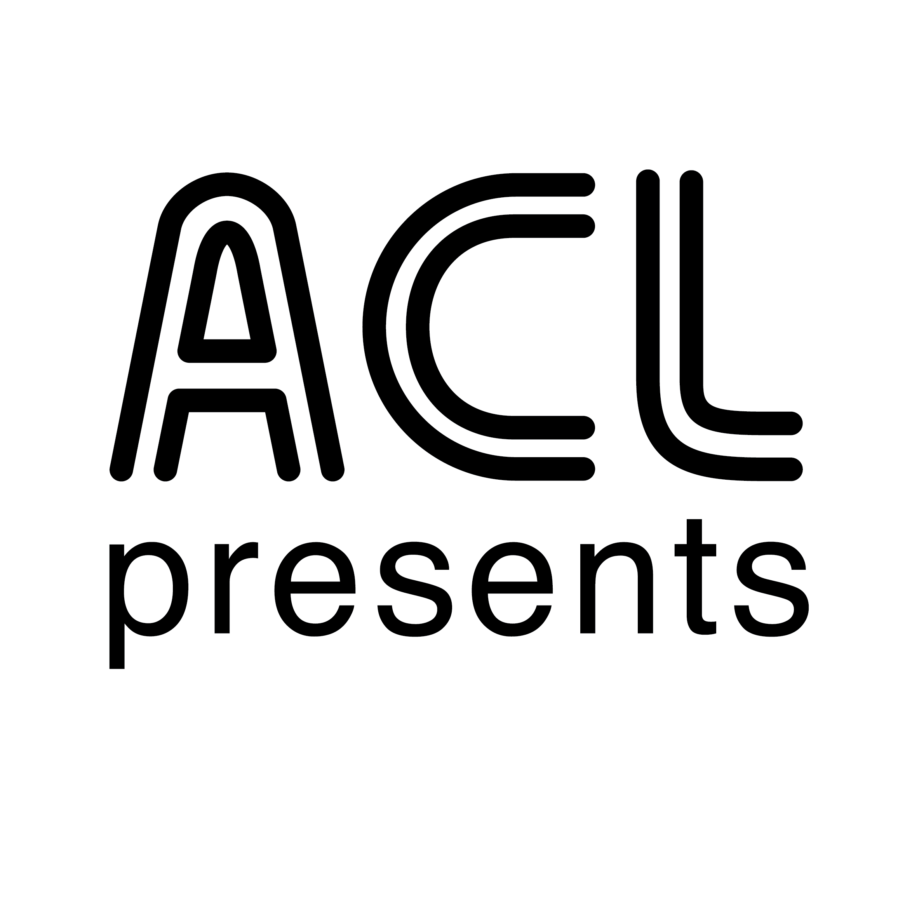
Austin City Limits Presents 50 Years of Asleep at the Wheel

Ten-Time Grammy-Winning Western Swing Band Partners with
Austin City Limits For Five-Decade Career Retrospective

Includes vintage footage from the band’s many appearances on the ACL stage; from the very first episode of ACL to modern-day performances with Willie Nelson, Lyle Lovett, Vince Gill and The Avett Brothers

Broadcast Premieres October 31 on PBS

October 28, 2020—Austin, TX—Austin City Limits (ACL) celebrates 50 years of western swing legends Asleep at the Wheel as the two Austin music institutions team up for an hour long retrospective. ACL Presents: 50 Years of Asleep at the Wheel offers a fascinating look at the Texas swing outfit’s evolution from the 1970s to the present via highlights from their many appearances on the ACL stage. The new installment premieres October 31 at 8pm CT/9pm ET on PBS. With live music still on pause, ACL continues to provide viewers a front-row seat to the best in live performance. The series airs weekly on PBS stations nationwide (check local listings) and full episodes are made available online for a limited time at pbs.org/austincitylimits immediately following the initial broadcast. The show's official hashtag is #acltv.

From the ever-changing cast of characters that make up Asleep at the Wheel, the 6’7” larger-than-life bandleader Ray Benson has been the one constant since the band’s inception in 1970. The ten-time Grammy Award-winners have released 31 albums and charted more than 20 singles on the country charts. Asleep at the Wheel has kept the western swing flame burning for five decades, and the revivalists are the chief practitioners, conspirators and caretakers of the genre, carrying the traditions well into the 21st century, reaching both their contemporaries and inspiring a new generation of artists.

Inducted into the ACL Hall of Fame in 2015, Asleep at the Wheel and Austin City Limits go way back, beginning with the program’s first official episode in 1976 (following Willie Nelson’s 1974 pilot episode). Their 11 iconic appearances are highlighted by classic and latter-day collaborations with special guests including Willie Nelson, Lyle Lovett, Johnny Gimble, Vince Gill and The Avett Brothers. The Wheel has woven a 50-year thread through Texas and American music history, and Austin City Limits has played a key role in documenting their remarkable run. The entertaining hour showcases the band’s rollicking journey through the decades ranging from their ‘76 performance of “The Letter That Johnny Walker Read,” to “I Can’t Give You Anything But Love” from 2015. Willie Nelson joins the band for multiple performances, including a 2009 appearance billed as Willie & The Wheel, singing the classics “Hesitation Blues” and “Pancho & Lefty” alongside the band’s stellar line-up of musicians. A highlight is a rarely-seen performance featuring Willie, Freddy Powers, and Johnny Gimble on the Tin Pan Alley standard “After You’ve Gone” from a 1981 pledge special, Swingin' Over the Rainbow. ACL opens up the original Studio 6A for Texas two-stepping during a vintage 1988 performance of the crowd pleaser “Boogie Back to Texas.” The late Texas Playboys’ singer Leon Rausch (then 88-years-old) joins the band for a show-stopping “Milk Cow Blues” during a 2015 outing. A few classic songs performed multiple times over the years, including “Take Me Back to Tulsa” and “Miles and Miles of Texas” are showcased in a compilation of the different performances.

In a recorded introduction to the special, fearless leader and founder Ray Benson remarks: “Forty-five years ago our band appeared on a newly formed show highlighting the Austin music scene called Austin City Limits...this was our introduction to the world.” “It was the beginning of what they would call the cosmic cowboy or outlaw music scene here in Austin where hippies and cowboys came together for some really amazing music. As we celebrate Asleep at the Wheel’s 50th Anniversary we thought it was appropriate to take a look back.”

ACL Presents: 50 Years of Asleep at the Wheel setlist:
“The Letter That Johnny Walker Read” - 1976
"Ain’t Nobody Here But Us Chickens” - 1978
“Get Your Kicks on Route 66” - 1996
"Roly Poly" ft. The Texas Playboys - 1993
“Hesitation Blues” ft. Willie Nelson - 2009
“Nothing Takes The Place of You” - 1976
“Blues for Dixie” ft. Lyle Lovett - 2015 ACL Hall of Fame
“Let Me Go Home Whiskey” - 1976
“After You’ve Gone” ft. Willie Nelson, Freddy Powers, and Johnny Gimble - 1981
“I Can’t Give You Anything But Love ”- 2015
“Boogie Back to Texas” - 1988
“Milk Cow Blues” - 2015
“Miles and Miles of Texas” - 1996, 2002, and 1980
“Choo Choo Boogie” - 1978, 1988, and 1996
“Pancho and Lefty” ft. Willie Nelson - 2009
“Take Me Back to Tulsa” ft. The Avett Brothers and Vince Gill - 1996, 2015, 1978, and 1976
“Cotton Eyed Joe” - 1980

Viewers can visit acltv.com for news regarding Season 46 live streams, future tapings and episode schedules or by following ACL on Facebook, Twitter and IG. . Fans can also browse the ACL YouTube channel for exclusive songs, behind-the-scenes videos and full-length artist interviews.

For images and episode information, visit Austin City Limits press room at http://acltv.com/press-room/.

About ACL Presents:

ACL Presents is music programming created by, or in association with, Austin PBS, KLRU-TV, the producers of Austin City Limits (ACL). ACL Presents programming includes television specials, live events, web series and recorded music presentations and is made in the spirit and standards of the legendary PBS series Austin City Limits, the longest-running live music series in television history. ACL Presents collaborations have included: Americana Music Festival with the Americana Music Association and Hardly Strictly Bluegrass with KQED.

About Austin City Limits

Austin City Limits (ACL) offers viewers unparalleled access to featured acts in an intimate setting that provides a platform for artists to deliver inspired, memorable, full-length performances. Now in its 46th Season, the program is taped live before a concert audience from The Moody Theater in downtown Austin. Austin City Limits is the longest-running music series in television history and remains the only TV series to ever be awarded the National Medal of Arts. Since its inception, the groundbreaking music series has become an institution that’s helped secure Austin’s reputation as the Live Music Capital of the World. The historic KLRU Studio 6A, home to 36 years of ACL concerts, has been designated an official Rock & Roll Hall of Fame Landmark. In 2011, ACL moved to the new venue ACL Live at The Moody Theater in downtown Austin. ACL received a rare institutional Peabody Award for excellence and outstanding achievement in 2012.

Austin City Limits is produced by Austin PBS, KLRU-TV and funding is provided in part by Dell Technologies, RigUp, the Austin Convention Center Department and Cirrus Logic. Additional funding is provided by the Friends of Austin City Limits. Learn more about Austin City Limits, programming and history at acltv.com.

Media Contact:
Maureen Coakley for ACL
maureen@coakleypress.com
t: 917.601.1229

