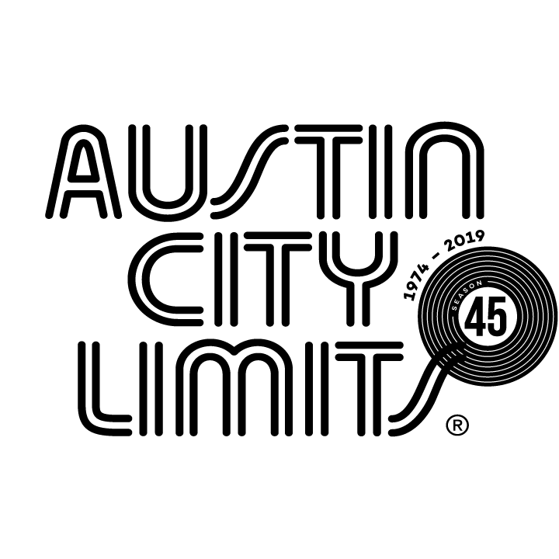

Austin City Limits Showcases Grammy Award-Winning Billie Eilish in Epic Hour

New Episode Premieres February 1 on PBS

Austin, TX—January 30, 2020—Austin City Limits (ACL) spotlights newly minted five-time Grammy Award winner Billie Eilish in an epic hour. The global pop phenomenon performs her off-kilter pop hits and songs from her acclaimed multi-platinum smash WHEN WE ALL FALL ASLEEP, WHERE DO WE GO? The penultimate episode of ACL’s Season 45, the broadcast premiere will launch Saturday, February 1 at 9pm ET/8pm CT on PBS and vary by market. Check local PBS listings for times. The episode will be available to music fans everywhere, streaming online the next day beginning Sunday, February 2 @10am ET at pbs.org/austincitylimits. Providing viewers a front-row seat to the best in live performance for a remarkable 45 years, the program airs weekly on PBS stations nationwide. Viewers can visit acltv.com for news regarding future tapings, episode schedules and select live stream updates. The show's official hashtag is #acltv.

18-year-old Los Angeles native Billie Eilish just swept the 2020 Grammy Awards, winning Best New Artist, Song, Record and Album of the Year, becoming only the second person in Grammy history to win all of the “Big Four” categories and the youngest person ever to win Album of the Year.

Eilish’s celebrated debut album, 2019’s WHEN WE ALL FALL ASLEEP, WHERE DO WE GO? is the centerpiece of her stunning ACL debut, and the striking neon-green clad teen commands the stage in an electrifying 14-song set, accompanied by her brother and collaborator FINNEAS, who earned his first Grammys as 2020 Producer of the Year for his sister’s debut.

Sporting a shock of lime-green hair and an oversized t-shirt, Eilish playfully saunters onstage to the electronic pulse of her Grammy-winning, No. 1 megahit, the pop-noir smash “bad guy,” as her whisper-speak vocals lend a sinister edge to this tale of dark seduction. She thrills on the thorny world domination fantasy “you should see me in a crown,” directing the delirious crowd to “sing as loud as you possibly can.” The innately groundbreaking artist remakes pop iconography and gives voice to 21st century teen ennui with lacerating songs about Gen Z angst, recreational drug use, heartbreak and self-destruction. Eilish performs the early career highlights that launched her meteoric rise: the sparse, synthy 2016 viral hit ballad “ocean eyes” (that generated a massive online following), and the spellbinding, melancholy “idontwannabeyouanymore,” from her 2017 EP Don’t Smile At Me.

A truly hypnotic performer, Eilish flaunts her range, singing with featherlight vocals and a lingering ache on the haunting heartbreak anthem “when the party’s over”—about going home angry and alone—before giving in to the sampled screams and grim impulses of the monster under the bed fever dream “bury a friend” for a riveting closer. The young star then descends into the rapt ACL audience, sweetly embracing her fans, enveloped in a screaming sea of hands and iPhones.

“Whether you’re already a hardcore fan, or you were captivated by her mesmerizing Grammy performance, this is a rare opportunity to see the many dimensions of Billie Eilish live in concert,” says ACL executive producer Terry Lickona. “An artist like Billie comes along once in a generation. Her Grammy sweep is historic; her ACL performance is historic.”

BILLIE EILISH setlist:
bad guy
my strange addiction
you should see me in a crown
idontwannabeyouanymore
copycat
when i was older
wish you were gay
xanny
all the good girls go to hell
ilomilo
bellyache
ocean eyes
when the party’s over
bury a friend
goodbye (outro)

Austin City Limits’ Season 45 finale airs February 8, 2020, featuring an hour with Grammy-winning Spanish singer-songwriter Rosalía. ACL continues to offer its popular live streams of select performances for fans worldwide on the ACL YouTube channel and will live stream the first taping of Season 46 with British country-soul sensation Yola, as she makes her ACL debut on February 4 at 9pm ET/8pm CT. Viewers can visit acltv.com for news regarding future Season 46 tapings, live stream events and episode schedules.

For images and episode information, visit Austin City Limits press room at http://acltv.com/press-room/.

About Austin City Limits
Austin City Limits (ACL) offers viewers unparalleled access to featured acts in an intimate setting that provides a platform for artists to deliver inspired, memorable, full-length performances. Now in its 45th Season, the program is taped live before a concert audience from The Moody Theater in downtown Austin. Austin City Limits is the longest-running music series in television history and remains the only TV series to ever be awarded the National Medal of Arts. Since its inception, the groundbreaking music series has become an institution that’s helped secure Austin’s reputation as the Live Music Capital of the World. The historic KLRU Studio 6A, home to 36 years of ACL concerts, has been designated an official Rock & Roll Hall of Fame Landmark. In 2011, ACL moved to the new venue ACL Live at The Moody Theater in downtown Austin. ACL received a rare institutional Peabody Award for excellence and outstanding achievement in 2012.
Austin City Limits is produced by Austin PBS, KLRU-TV and funding is provided in part by Dell Technologies, American Airlines, the Austin Convention Center Department and Cirrus Logic. Additional funding is provided by the Friends of Austin City Limits. Learn more about Austin City Limits, programming and history at acltv.com.

Press contact:
Maureen Coakley for ACL
maureen@coakleypress.com
T: 917.601.1229

