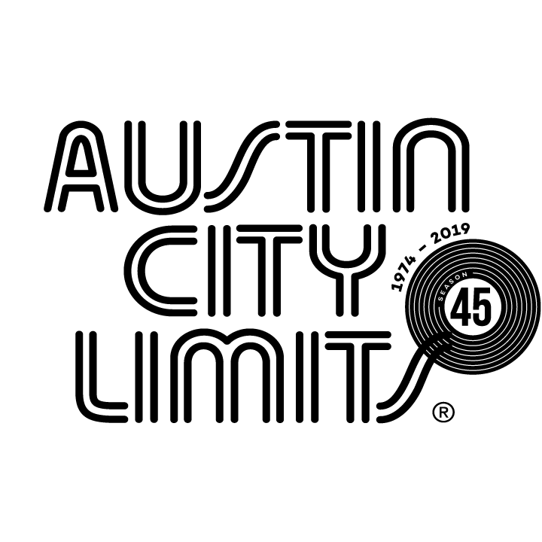
Austin City Limits Showcases One of Rock’s Biggest Live Acts:
Cage The Elephant & Introduces 2020 “Best New Artist” Grammy Nominee
Tank and the Bangas

New Episode Premieres January 23 on PBS

Austin, TX—January 23, 2020—Austin City Limits (ACL) spotlights thrilling live bands in a new installment featuring rock giants Cage The Elephant, one of music’s biggest live acts. The hour also introduces a 2020 “Best New Artist” GRAMMY nominee, New Orleans breakout act Tank and the Bangas. The broadcast premieres Saturday, January 25 at 8pm CT/9pm ET on PBS. The episode will be available to music fans everywhere, streaming online the next day beginning Sunday, January 26 @10am ET at pbs.org/austincitylimits. Providing viewers a front-row seat to the best in live performance for a remarkable 45 years, the program airs weekly on PBS stations nationwide (check local listings for times) and full episodes are made available online for a limited time at pbs.org/austincitylimits immediately following the initial broadcast. Viewers can visit acltv.com for news regarding future tapings, episode schedules and select live stream updates. The show's official hashtag is #acltv.

Hailing from Kentucky, the Nashville-based six-piece Cage The Elephant perform tracks from their acclaimed fifth album Social Cues, alongside career highlights in a stellar, hit-filled set. Charismatic lead singer/live wire Matt Shultz takes the stage in a signature makeshift outfit: elbow-length blue gloves, blue tights adorned with women’s lace underwear, headphones and goggles. A wardrobe rack and a trunk filled with props sit onstage amidst the amplifiers, as the shape-shifting frontman changes outfits with each song. “It’s a lot of work wearing all these different personalities,” says Shultz, while seamlessly delivering a seven-song set of his ubiquitous alternative-rock hits. Opening with the new wave-heavy smash “Broken Boy,” Shultz, known for his wild antics, stalks the stage in a can’t-look-away performance. Reaching back to 2015’s GRAMMY-winning Tell Me I’m Pretty for “Cold Cold Cold,” Shultz changes into fluorescent yellow fishermen’s gear, and ventures into the audience, sprinting into the bleachers and sliding down the steps backward on his head. Without missing a beat, the hit parade continues with melodic charmer “Trouble,” as the crowd sings along with every word; an iconic slide guitar riff next signals the 2008 breakthrough hit “Ain’t No Rest for the Wicked,” as Shultz dons a fishnet face mask and climbs onto the P.A. for the Cage classic. The band closes out with radio smash “Come a Little Closer,” turned into a raucous, audience participation anthem.

“Matt Shultz takes the prize for the most wardrobe changes in a single show in ACL history,” laughs ACL executive producer Terry Lickona. “Who knew? Nobody knows quite what to expect from Cage The Elephant, and that’s a big part of why their fans love them so much.”

New Orleans five-piece R&B, funk and hip-hop outfit Tank and the Bangas shine in a radiant ACL debut featuring songs from the 2019 major label debut Green Balloon. A unit where jazz meets hip-hop, soul meets rock, and funk is the heartbeat of all they do, this versatile act came together in 2011 at a NOLA open mic event, and got propelled into the national limelight when they unanimously won NPR’s Tiny Desk Contest in 2017. The Big Easy band takes viewers on a handclapping, swaying, joyous ride through its world. Former slam poet and magnetic lead singer Tank Ball shifts from a lilting sing-song to deep and forceful rapping on set opener “Spaceships”. The Bangas keep the music rolling and solos flying as Tank unleashes her powerful vocal on “Ripperton Love,” in tribute to R&B legend Minnie Ripperton. On the soulful meditation “Hot Air Balloons,” Ball explores her elastic voice as the band provides an other-worldly soundscape building to a fiery sax solo. Set-closer “The Brady’s” has it all: sweet harmonies, crashing drums, rock guitar and relentless groove, anchored by Tank’s colorful vocal stylings.

“Tank and the Bangas radiate joy, and their set is nothing but a musical joy ride,” says Lickona. “The world needs Tank and the Bangas more now than ever.”

CAGE THE ELEPHANT setlist:
BROKEN BOY
COLD COLD COLD
SOCIAL CUES
TROUBLE
TELESCOPE
AIN’T NO REST FOR THE WICKED
COME A LITTLE CLOSER

TANK AND THE BANGAS setlist:
SPACESHIPS
RIPPERTON LOVE
HOT AIR BALLOON
THE BRADY'S

Season 45 Broadcast Schedule:

February 1 Billie Eilish
February 8 Rosalía (Season 45 finale)

Austin City Limits continues to offer its popular live streams of select performances for fans worldwide on ACL's YouTube Channel. Viewers can visit acltv.com for news regarding live streams, future Season 46 tapings and episode schedules.

For images and episode information, visit Austin City Limits press room at http://acltv.com/press-room/.

Press contact:
Maureen Coakley for ACL
maureen@coakleypress.com
T: 917.601.1229

