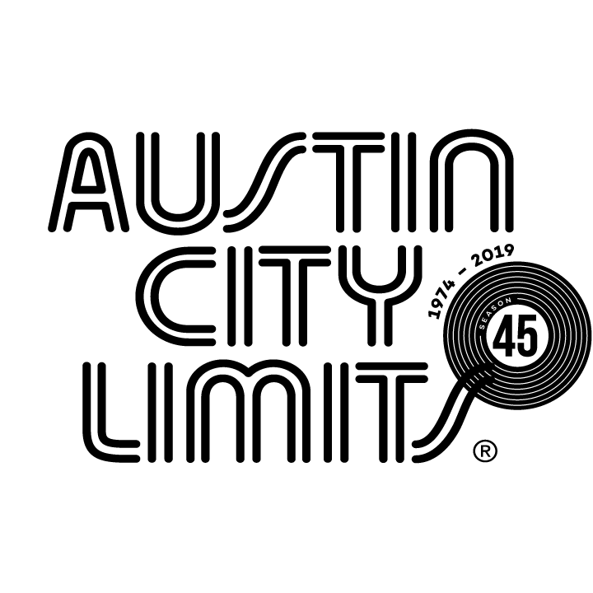

Austin City Limits Spotlights Indie Originals Mitski & Rainbow Kitten Surprise

New Episode Premieres January 18 on PBS

January 16, 2020—Austin, TX—Austin City Limits (ACL) showcases a pair of innovators in a captivating double bill: acclaimed indie songwriter and performer Mitski in a rare television performance and eclectic alt-rockers Rainbow Kitten Surprise. The hourlong broadcast premieres Saturday, January 18 at 8pm CT/9pm ET on PBS. The episode will be available to music fans everywhere, streaming online the next day beginning Sunday, January 19 @10am ET at pbs.org/austincitylimits. Providing viewers a front-row seat to the best in live performance for a remarkable 45 years, the program airs weekly on PBS stations nationwide (check local listings for times) and full episodes are made available online for a limited time at pbs.org/austincitylimits immediately following the initial broadcast. Viewers can visit acltv.com for news regarding future tapings, episode schedules and select live stream updates. The show's official hashtag is #acltv.

Critically acclaimed as the vanguard of indie rock, Japanese-born American Mitski Miyawaki performs songs from her stunning fifth album Be the Cowboy alongside career highlights in her ACL debut. The singer-songwriter pulls the curtain back on her emotionally raw songs in a spellbinding 8-song set backed by her 4-piece band. The innovative artist has a singular performance style that plays out like conceptual art; the stage is set with a white wooden table and chair, basic props that are repurposed as a platform, a screen and a shield as the show unfolds. Wearing black shorts, knee pads and dance shoes, and armed with a stone-cold stare, Mitski moves slowly, deliberately, opening with the passionate, throbbing “I Will,” from 2014’s Bury Me At Makeout Creek, climbing atop the prop table victoriously at the song’s climax. With velvety tones and incisive poetry, she raises her voice on love and loneliness, coaxing the rapt audience to enter the darkest parts of her mind, to swirl in her insecurities, to stand at her side as she vanquishes residual longing from love gone wrong. On her knees on the table as guitarist (and longtime producer) Patrick Hyland strums the chords to the anthem “Your Best American Girl,” from her 2016 breakout Puberty 2, Mitski rides the gorgeous swells of sound, whipping her hair, before delivering a gut-wrenching performance of “I Bet on Losing Dogs” that leaves her curled in a fetal position on top of the table. The performance is a meticulously detailed exercise in vulnerability and cathartic release, for one of the most compelling performances ever on the ACL stage.

“Performance is as much a part of Mitski’s show as the songs are - maybe even more so,” said ACL executive producer Terry Lickona. “I guarantee that if you’re a longtime fan of ACL, you’ve neve seen anything quite like this.”

Nashville-based five-piece Rainbow Kitten Surprise formed at Appalachian State University in 2013 and make their ACL debut drawing heavily from their acclaimed third album How To: Friend, Love, Freefall. Opening with the fan-favorite “Hide,” the song is amplified by singer Sam Melo’s soulful vocals and bitter cries of “You better hide your love!” The high-spirited alt-rockers deliver a blissed-out free-for-all, with charismatic frontman Melo engaging in unpredictable bursts of physical expression, from high kicks to swirling twirls to near-leaps into the crowd and bassist/sparkplug Charlie Holt often mirroring his jumps and dips. This joyful vitality and powerful camaraderie infuse the music’s kaleidoscopic sonic palette with inventive arrangements and indelible melody. Set highlights include “Cocaine Jesus,” augmented by a cappella harmonies and “When It Lands,” an ambitious, multi-movement composition that showcases each member’s talents. Melo is behind the piano as he croons the intro to the dramatic “Holy War,” before retaking the mic at center stage for the tumbling folk of set-closer “Painkillers.”

“If you haven’t experienced seeing Rainbow Kitten Surprise, you are missing something in your life,” said Lickona. “The combo of jump kicks, their original electro-folk sound and ghostly harmonies will carry you away to psychedelic Neverland.”

MITSKI setlist:
I WILL
I DON'T SMOKE
YOUR BEST AMERICAN GIRL
I BET ON LOSING DOGS
DRUNK WALK HOME
HAPPY
TWO SLOW DANCERS
CARRY ME OUT

RAINBOW KITTEN SURPRISE setlist:
HIDE
COCAINE JESUS
WHEN IT LANDS
ALL'S WELL THAT ENDS
HOLY WAR
PAINKILLERS

Season 45 Broadcast Schedule:

January 25 Cage The Elephant/Tank and The Bangas
February 1 Billie Eilish
February 8 Rosalía (season finale)

Austin City Limits continues to offer its popular live streams of select performances for fans worldwide on ACL's YouTube Channel. Viewers can visit acltv.com for news regarding live streams, future Season 46 tapings and episode schedules.

For images and episode information, visit Austin City Limits press room at http://acltv.com/press-room/.

Press contact:
Maureen Coakley for ACL
maureen@coakleypress.com
T: 917.601.1229

