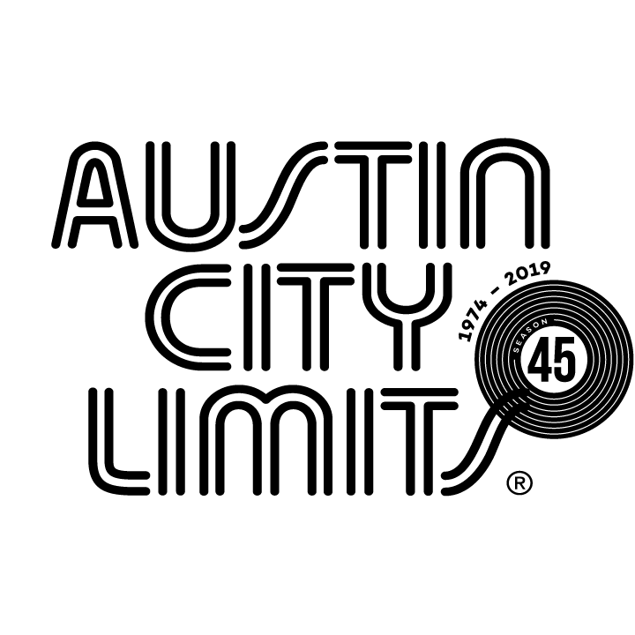
Austin City Limits Showcases Indie Originals Sharon Van Etten and Lucy Dacus

New Episode Premieres January 4 on PBS

Austin, TX—December 30, 2019—Austin City Limits (ACL) rings in the new decade with a new installment showcasing a pair of indie-rock singer-songwriters, Sharon Van Etten and Lucy Dacus, in a spellbinding double bill that forecasts the genre’s future. The hourlong broadcast premieres Saturday, January 4 at 8pm CT/9pm ET on PBS. The episode will be available to music fans everywhere to stream online beginning Sunday, January 5 @10am ET at pbs.org/austincitylimits. Providing viewers a front-row seat to the best in live performance for a remarkable 45 years, the program airs weekly on PBS stations nationwide (check local listings for times) and full episodes are made available online for a limited time at pbs.org/austincitylimits immediately following the initial broadcast. Viewers can visit acltv.com for news regarding future tapings, episode schedules and select live stream updates. The show's official hashtag is #acltv.

Sharon Van Etten makes her ACL debut performing highlights from Remind Me Tomorrow, her celebrated fifth studio album and first record in five years, which has also landed on a multitude of 2019’s Year-End Best lists. A career highlight, Remind Me Tomorrow finds the indie mainstay veering full-force towards the driving, dark glimmer moods that have illuminated the edges of her work throughout her decade-long career. Wearing a sparkling silver metallic suit, Van Etten opens the electrifying six-song set with “Comeback Kid,” a feral gutpunch as the singer prowls the stage in full command of her powers. She reaches back to 2014’s Are We There for “Tarifa,” before delivering sonic gems from her latest: “You Shadow,” “Hands,” and “I Told You Everything,” then unleashes the breathtaking, primal scream of rapturous rock anthem “Seventeen.”

Lucy Dacus performs songs from her acclaimed 2018 sophomore release Historian in her ACL debut. Backed by her three-piece band, the 24-year-old Richmond, Virginia native showcases the bravely intimate songwriting, with lyrics of heartbreak and loss, that has earned her a loyal fan base and made her an in-demand live act. Dacus sings the number that introduced her talents to the world, the pointed breakout single “I Don’t Wanna Be Funny Anymore” from her 2016 indie debut No Burden, as well as “Forever Half Mast,” a Fourth of July-themed rock blitz from her recent 2019 EP, a collection of songs pegged to notable days on the calendar. Dacus closes out the captivating set with an unabashedly emotional “Night Shift,” building the initially tranquil rocker into a glorious wall of distortion.

SHARON VAN ETTEN setlist:
COMEBACK KID
TARIFA
YOU SHADOW
HANDS
I TOLD YOU EVERYTHING
SEVENTEEN

LUCY DACUS setlist:
YOURS & MINE
ADDICTIONS
FOREVER HALF MAST
I DON'T WANNA BE FUNNY ANYMORE
NIGHT SHIFT

Season 45 Broadcast Schedule:

January 11 The Raconteurs/Black Pumas
January 18 Mitski/Rainbow Kitten Surprise
January 25 Cage The Elephant/Tank and The Bangas
February 1 Billie Eilish
February 8 Rosalía

Austin City Limits continues to offer its popular live streams of select performances for fans worldwide on ACL's YouTube Channel. Viewers can visit acltv.com for news regarding live streams, future Season 46 tapings and episode schedules.

For images and episode information, visit Austin City Limits press room at http://acltv.com/press-room/.

About Austin City Limits
Austin City Limits (ACL) offers viewers unparalleled access to featured acts in an intimate setting that provides a platform for artists to deliver inspired, memorable, full-length performances. Now in its 45th Season, the program is taped live before a concert audience from The Moody Theater in downtown Austin. Austin City Limits is the longest-running music series in television history and remains the only TV series to ever be awarded the National Medal of Arts. Since its inception, the groundbreaking music series has become an institution that’s helped secure Austin’s reputation as the Live Music Capital of the World. The historic KLRU Studio 6A, home to 36 years of ACL concerts, has been designated an official Rock & Roll Hall of Fame Landmark. In 2011, ACL moved to the new venue ACL Live at The Moody Theater in downtown Austin. ACL received a rare institutional Peabody Award for excellence and outstanding achievement in 2012.
Austin City Limits is produced by Austin PBS, KLRU-TV and funding is provided in part by Dell Technologies, American Airlines, the Austin Convention Center Department and Cirrus Logic. Additional funding is provided by the Friends of Austin City Limits. Learn more about Austin City Limits, programming and history at acltv.com.

Press contact:
Maureen Coakley for ACL
maureen@coakleypress.com
T: 917.601.1229

