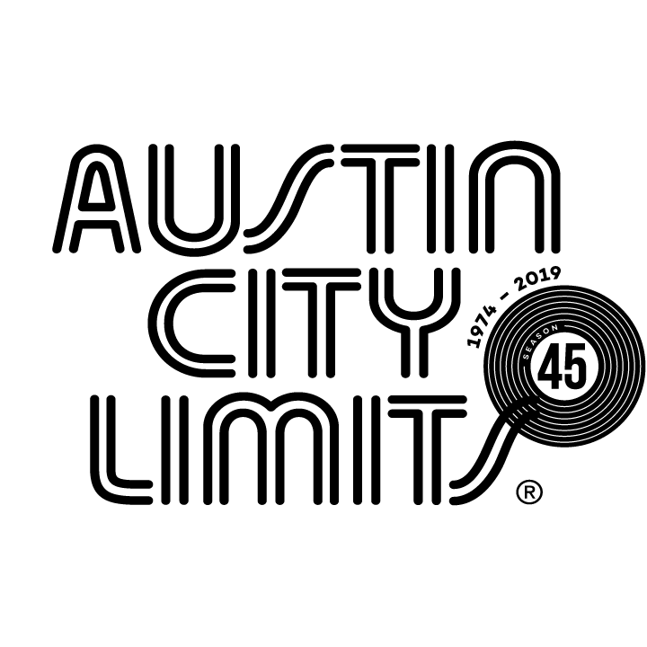
Austin City Limits Showcases Vampire Weekend in Career-Spanning Hour

Broadcast Premieres November 9 on PBS

Austin, TX—November 7, 2019—Austin City Limits (ACL) spotlights Vampire Weekend in a must-see hour featuring the indie-rock band’s epic return showcasing their long-awaited new album Father of the Bride alongside classic gems from their catalog. The installment premieres Saturday, November 9 at 8pm CT/9pm ET on PBS. Providing viewers a front-row seat to the best in live performance for a remarkable 45 years, the program airs weekly on PBS stations nationwide (check local listings for times) and full episodes are made available online for a limited time at pbs.org/austincitylimits immediately following the initial broadcast. Viewers can visit acltv.com for news regarding future tapings, episode schedules and select live stream updates. The show's official hashtag is #acltv.

Vampire Weekend performs a suite of songs off the celebrated, chart-topping Father of the Bride, their fourth album and first in six years. The seven-piece, led by frontman Ezra Koenig, unpack new gems: “Sympathy,” “Bambina,”“2021,” “My Mistake,” and “This Life,” showcasing their irresistible knack for melody and lyrics that capture the complexities of 21st-century life. The group perform select favorites from their catalog, including the breakthrough “A-Punk” from their 2008 debut and the rhythmic, Afrobeat “White Sky” from 2010’s landmark Contra. Koenig’s 2014 collaboration with EDM producer SBTRKT, “New Dorp. New York,” is here transformed into a Vampire Weekend funk-rock epic. A set highlight is an extended version of new classic “Harmony Hall,” a masterful, melodic wonder that opens with an iconic guitar riff and accelerates into a joyful piano sprint. The perfectly-paced set comes to a powerful close with Koenig’s stunning vocal on the hymnal, cathartic anthem “Jerusalem, New York, Berlin”.

“There’s never been a better time to appreciate Vampire Weekend, given the world we live in today,” said ACL executive producer Terry Lickona. “I’ve always been a fan of Ezra Koenig’s voice and his new songs are more personal and inward-looking than ever. Vampire Weekend has remained tried-and-true – popular without ever becoming pop!”

Vampire Weekend setlist:
SYMPATHY
WHITE SKY
BAMBINA
2021
MY MISTAKE
NEW DORP, NEW YORK
THIS LIFE
HARMONY HALL
A-PUNK
JERUSALEM, NEW YORK, BERLIN

Season 45 Upcoming Broadcasts (seven new episodes to be announced):

November 16 Kane Brown / Colter Wall
November 23 ACL Presents Americana 18th Annual Honors

The complete line-up for the full 14-week season, including seven new episodes to air beginning December 31, 2019, will be announced shortly. Austin City Limits continues to offer its popular live streams of select performances for fans worldwide on ACL's YouTube Channel. Viewers can visit acltv.com for news regarding live streams, future tapings and episode schedules.

For images and episode information, visit Austin City Limits press room at http://acltv.com/press-room/.

About Austin City Limits
Austin City Limits (ACL) offers viewers unparalleled access to featured acts in an intimate setting that provides a platform for artists to deliver inspired, memorable, full-length performances. The program is taped live before a concert audience from The Moody Theater in downtown Austin. Austin City Limits is the longest-running music series in television history and remains the only TV series to ever be awarded the National Medal of Arts. Since its inception, the groundbreaking music series has become an institution that's helped secure Austin's reputation as the Live Music Capital of the World. The historic KLRU Studio 6A, home to 36 years of ACL concerts, has been designated an official Rock & Roll Hall of Fame Landmark. In 2011, ACL moved to the new venue ACL Live at The Moody Theater in downtown Austin. ACL received a rare institutional Peabody Award for excellence and outstanding achievement in 2012.

Austin City Limits is produced by KLRU-TV and funding is provided in part by Dell Technologies, American Airlines, the Austin Convention Center Department and Cirrus Logic. Additional funding is provided by the Friends of Austin City Limits. Learn more about Austin City Limits, programming and history at acltv.com.

