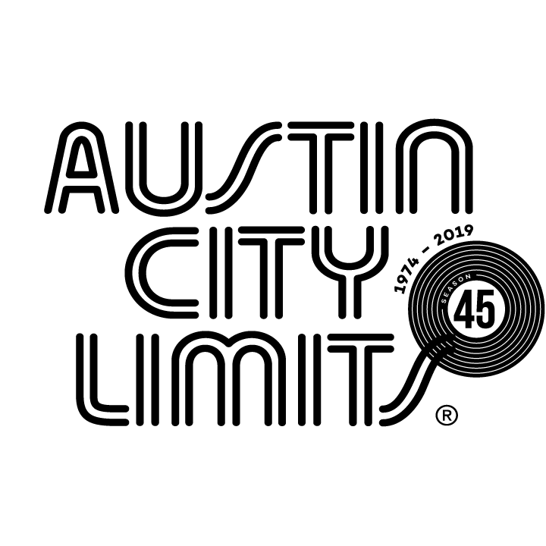
AUSTIN CITY LIMITS SHOWCASES AMERICAN ROOTS MUSIC WITH PATTY GRIFFIN AND THE REVIVALISTS

New Episode Premieres November 2 on PBS

Austin, TX—October 30, 2019—Austin City Limits (ACL) showcases American roots music with Texas singer-songwriter Patty Griffin and New Orleans rockers The Revivalists in a new installment as part of ACL’s milestone Season 45. Griffin performs an intimate, stripped-down set highlighting songs from her recent self-titled release and The Revivalists play crowd-pleasing anthems from their latest Take Good Care. The broadcast premieres Saturday, November 2 at 8pm CT/9pm ET on PBS. Providing viewers a front-row seat to the best in live performance for a remarkable 45 years, the program airs weekly on PBS stations nationwide (check local listings for times) and full episodes are made available online for a limited time at pbs.org/austincitylimits immediately following the initial broadcast. Viewers can visit acltv.com for news regarding future tapings, episode schedules and select live stream updates. The show's official hashtag is #acltv.

Patty Griffin delivers a powerful performance with songs from her new self-titled release, her tenth studio album — the first after a four-year hiatus. The Austin favorite first appeared on ACL in a songwriters’ special in 2000, and she returns for her sixth appearance on our stage, adding another extraordinary chapter to her storied two-decade career. Accompanied by guitarist David Pulkingham and percussionist/multi-instrumentalist Conrad Choucroun, Griffin performs highlights from her latest, including the new single “The Wheel”, along with “Luminous Places” and “Hourglass”. The Austin-based musician introduces “Boys From Tralee,” a Celtic-folk stunner that tells the story of her Irish ancestors’ emigration to the United States. Griffin dips back to 2004’s Impossible Dream for the bluesy gut-punch “Standing”, showcasing her rich vocals and love of gospel.

“We take great pride in claiming Patty as one of our own here in Austin,” said ACL executive producer Terry Lickona, “ but the truth is that her songs have captured the hearts and souls of millions of fans the world over.”

Chart-topping New Orleans brass-rockers The Revivalists perform an irresistible set filled with get-up-and-dance gems from their acclaimed 2018 album Take Good Care. The road-tested band, who’ve perfected their energetic live show with over a decade of non-stop touring, take the crowd on an emotional rollercoaster with infectious slow-build numbers that escalate to anthems. The eight-piece outfit open with their platinum-selling 2015 breakthrough, “Wish I Knew You,” the nostalgic funk jam that became a Number One Billboard smash. Lead singer David Shaw strikes a chord with his signature soulful howl and the group showcase their love for old-school soul on set-closer “Got Love”.

“The Revivalists won me over the day I saw them play at New Orleans’ Jazzfest,” said ACL executive producer Terry Lickona. “They may not have that typical New Orleans sound that comes to mind, but they have the grit, the funk, and the spice to create their own special kind of musical gumbo.”

PATTY GRIFFIN setlist:
THE WHEEL
BOYS FROM TRALEE
STANDING
LUMINOUS PLACES
HOURGLASS

THE REVIVALISTS setlist:
WISH I KNEW YOU
OH NO
CHANGE
YOU SAID IT ALL
OTHERSIDE OF PARADISE
GOT LOVE

Season 45 Broadcast Line-up (seven new episodes to be announced):

October 5 Gary Clark Jr.
October 12 Maggie Rogers
October 19 Steve Earle & The Dukes: A Tribute to Guy Clark
October 26 H.E.R.
November 2 Patty Griffin / The Revivalists
November 9 Vampire Weekend
November 16 Kane Brown / Colter Wall
November 23 ACL Presents Americana 18th Annual Honors

The complete line-up for the full 14-week season, including seven new episodes to air beginning December 31, 2019, will be announced at a later date. Austin City Limits continues to offer its popular live streams of select performances for fans worldwide on ACL's YouTube Channel. Viewers can visit acltv.com for news regarding live streams, future tapings and episode schedules.

For images and episode information, visit Austin City Limits press room at http://acltv.com/press-room/.

About Austin City Limits
Austin City Limits (ACL) offers viewers unparalleled access to featured acts in an intimate setting that provides a platform for artists to deliver inspired, memorable, full-length performances. The program is taped live before a concert audience from The Moody Theater in downtown Austin. Austin City Limits is the longest-running music series in television history and remains the only TV series to ever be awarded the National Medal of Arts. Since its inception, the groundbreaking music series has become an institution that's helped secure Austin's reputation as the Live Music Capital of the World. The historic KLRU Studio 6A, home to 36 years of ACL concerts, has been designated an official Rock & Roll Hall of Fame Landmark. In 2011, ACL moved to the new venue ACL Live at The Moody Theater in downtown Austin. ACL received a rare institutional Peabody Award for excellence and outstanding achievement in 2012.

Austin City Limits is produced by KLRU-TV and funding is provided in part by Dell Technologies, American Airlines, the Austin Convention Center Department and Cirrus Logic. Additional funding is provided by the Friends of Austin City Limits. Learn more about Austin City Limits, programming and history at acltv.com.

Media Contact:
Maureen Coakley for ACL
maureen@coakleypress.com
t: 917.601.1229

