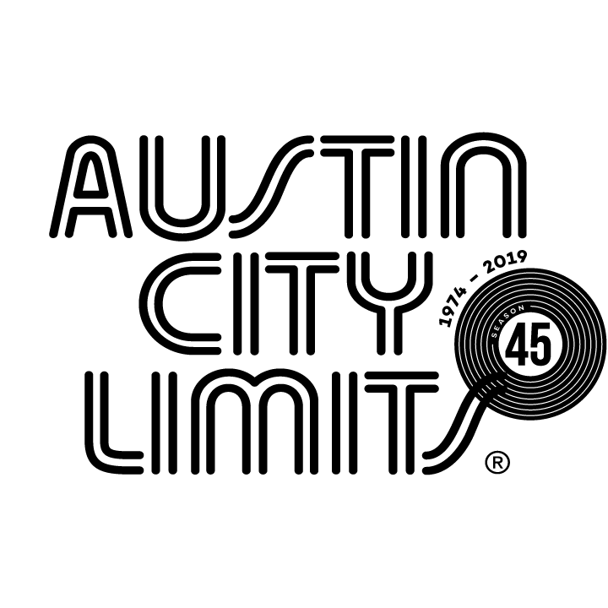

Austin City Limits Showcases Steve Earle & The Dukes: A Tribute to Guy Clark

Joined by Special Guests Rodney Crowell, Joe Ely, Terry Allen & Jo Harvey Allen

Special Hour Premieres October 19 on PBS

Austin, TX—October 18, 2019—Austin City Limits (ACL) presents a Season 45 highlight: Steve Earle & The Dukes spotlighting the songwriting legacy of the legendary Guy Clark. Americana stalwart Earle makes his fifth appearance on the ACL stage paying tribute to his mentor, the late Texas singer-songwriter and ACL Hall of Fame legend Guy Clark, in a heartwarming hour filled with choice classics and personal anecdotes. Performing a collection of gems from his acclaimed Clark tribute album Guy, Earle is accompanied by his five-piece band The Dukes, and special guests including Rodney Crowell, Joe Ely, Terry Allen and Jo Harvey Allen. The episode is capped with vintage clips from Clark’s own ACL appearances including his 1977 debut. The must-see hour premieres Saturday, October 19 at 8pm CT/9pm ET as part of ACL’s milestone Season 45. Providing viewers a front-row seat to the best in live performance for a remarkable 45 years, the program airs weekly on PBS stations nationwide (check local listings for times) and full episodes are made available online for a limited time at pbs.org/austincitylimits immediately following the initial broadcast. Viewers can visit acltv.com for news regarding future tapings, episode schedules and select live stream updates. The show's official hashtag is #acltv.

Steve Earle kicks off the hour appropriately singing “I wish I was in Austin...,” the infamous opening of Guy Clark’s “Dublin Blues.” In his signature bandana, the Americana maverick Earle showcases a true Texas icon in this moving hour, filled with entertaining stories and personal tales from Earle’s longtime relationship with one of his main songwriting influences. Earle explains how he, at 19, first met Guy after hitchhiking from Texas to Tennessee, eventually playing bass in Clark’s band “until Guy needed a better bass player.” Earle shares the stage with special guests: Texas legend Joe Ely joins Earle for the beloved Clark signature “Desperadoes Waiting For A Train”; and Rodney Crowell collaborates on a rousing duet of “Heartbroke”, an early nugget Crowell first recorded in 1980. Earle performs a stunning solo acoustic reading of “Randall Knife,” adding his own powerful take on a Clark classic. “I guess I should play a couple of songs of mine so y’all won’t think Guy didn’t teach me anything,” quips Earle before launching into gorgeous renditions of a pair of his own: “Guitar Town,” the 1986 track that introduced Earle’s talents to the world, and “Copperhead Road”. “That’s what I learned from Guy Clark,” asserts Earle before bringing Ely and Crowell back, joined by Lubbock legends Terry Allen and Jo Harvey Allen, saying “Everyone here loved Guy Clark.” The Texas natives close out the hour together with a poignant rendition of the Clark gem, “Old Friends,” as each artist takes a turn at the mic: “...Old friends they shine like diamonds.” Earle leads the audience in a final round of the chorus, before calling out directly to his songwriting hero at the close: “Guy Charles Clark—see you when I get there maestro.”

“There’s nobody better suited personally, musically, or emotionally to bring new life to the songs of Guy Clark than Steve Earle,” says ACL executive producer Terry Lickona. “Guy’s songs are timeless, but Steve makes sure that nobody will forget why he will always be considered the Dean of Texas songwriters.”

STEVE EARLE & THE DUKES setlist:
DUBLIN BLUES
TEXAS 1947
RITA BALLOU
DESPERADOS WAITING FOR A TRAIN (w/ Joe Ely)
THE LAST GUNFIGHTER BALLAD
RANDALL KNIFE
LA FREEWAY
NEW CUT ROAD
HEARTBROKE (w/ Rodney Crowell)
GUITAR TOWN
COPPERHEAD ROAD
OLD FRIENDS (w/ Joe Ely, Rodney Crowell, Terry Allen and Jo Harvey Allen)

Season 45 Broadcast Line-up (seven new episodes to be announced):

October 5 Gary Clark Jr.
October 12 Maggie Rogers
October 19 Steve Earle & The Dukes: A Tribute to Guy Clark
October 26 H.E.R.
November 2 Patty Griffin / The Revivalists
November 9 Vampire Weekend
November 16 Kane Brown / Colter Wall
November 23 ACL Presents Americana 18th Annual Honors

The complete line-up for the full 14-week season, including seven new episodes to air beginning December 31, 2019, will be announced at a later date. Austin City Limits continues to offer its popular live streams of select performances for fans worldwide on ACL's YouTube Channel. Viewers can visit acltv.com for news regarding live streams, future tapings and episode schedules.

For images and episode information, visit Austin City Limits press room at http://acltv.com/press-room/.

About Austin City Limits
Austin City Limits (ACL) offers viewers unparalleled access to featured acts in an intimate setting that provides a platform for artists to deliver inspired, memorable, full-length performances. The program is taped live before a concert audience from The Moody Theater in downtown Austin. Austin City Limits is the longest-running music series in television history and remains the only TV series to ever be awarded the National Medal of Arts. Since its inception, the groundbreaking music series has become an institution that's helped secure Austin's reputation as the Live Music Capital of the World. The historic KLRU Studio 6A, home to 36 years of ACL concerts, has been designated an official Rock & Roll Hall of Fame Landmark. In 2011, ACL moved to the new venue ACL Live at The Moody Theater in downtown Austin. ACL received a rare institutional Peabody Award for excellence and outstanding achievement in 2012.

Austin City Limits is produced by KLRU-TV and funding is provided in part by Dell Technologies, American Airlines, the Austin Convention Center Department and Cirrus Logic. Additional funding is provided by the Friends of Austin City Limits. Learn more about Austin City Limits, programming and history at acltv.com.

Media Contact:

Maureen Coakley for ACL
maureen@coakleypress.com
t: 917.601.1229

