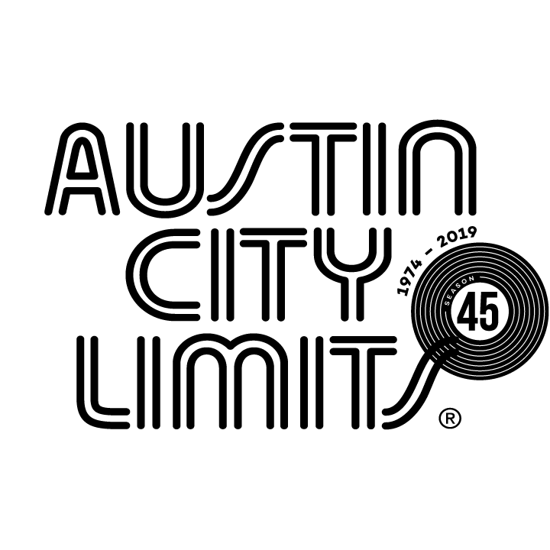
Austin City Limits Showcases Acclaimed Producer, Songwriter, and Performer Maggie Rogers

Sparkling Hour Premieres October 12 on PBS

Austin, TX—October 10, 2019—Austin City Limits (ACL) showcases acclaimed artist Maggie Rogers in a sparkling hour premiering Saturday, October 12 at 8pm CT/9pm ET as part of ACL’s milestone Season 45. Providing viewers a front-row seat to the best in live performance for a remarkable 45 years, the program airs weekly on PBS stations nationwide (check local listings for times) and full episodes are made available online for a limited time at pbs.org/austincitylimits immediately following the initial broadcast. Viewers can visit acltv.com for news regarding future tapings, episode schedules and select live stream updates. The show's official hashtag is #acltv.

Maggie Rogers makes her ACL debut in an irresistible hour showcasing songs from her Capitol Records debut album Heard It In A Past Life. Raised in rural Easton, Maryland, the 25-year-old phenom delivers a captivating rendition of “Alaska,” the breakout song that became a viral sensation and introduced her talents as a songwriter and producer to the world. Heard It In Past Life entered Billboard’s Top Album Sales chart at No. 1 and debuted at No. 2 on the Billboard 200 Chart. The album sold over 200, 000 album adjusted units, amassed over 500 million combined streams and received widespread critical praise from NPR, The New York Times, Rolling Stone, Pitchfork, TIME Magazine, Billboard and many more.

Her buoyant 11-song set is filled with open-hearted anthems about love and relationships including chart-topping fan-favorites “Light On” and “Fallingwater.” Rogers dances ecstatically across the stage, glowing as she moves with her music’s creative beats. With barefaced honesty, she inspires a genuine connection with her audience, and the admiring Austin crowd sings along passionately on the choruses. The magnetic artist closes out the standout hour alone on the stage for a gorgeous a cappella performance of “Color Song,” signaling an enduring new talent has arrived.

“Maggie’s music is 100% emotion,” says ACL executive producer Terry Lickona, “and her live performances are exuberant and unfettered in a way you seldom see on a stage. Her music celebrates life, and Maggie Rogers is a gift to us all.”

Maggie Rogers episode setlist:
GIVE A LITTLE
BURNING
SAY IT
ON + OFF
DOG YEARS
RETROGRADE
LIGHT ON
PAST LIFE
ALASKA
FALLINGWATER
COLOR SONG

Season 45 Broadcast Line-up (seven new episodes to be announced):

October 5 Gary Clark Jr.
October 12 Maggie Rogers
October 19 Steve Earle & The Dukes: A Tribute to Guy Clark
October 26 H.E.R.
November 2 Patty Griffin / The Revivalists
November 9 Vampire Weekend
November 16 Kane Brown / Colter Wall
November 23 ACL Presents Americana 18th Annual Honors

The complete line-up for the full 14-week season, including seven new episodes to air beginning December 31, 2019, will be announced at a later date. Austin City Limits continues to offer its popular live streams of select performances for fans worldwide on ACL's YouTube Channel. Viewers can visit acltv.com for news regarding live streams, future tapings and episode schedules.

For images and episode information, visit Austin City Limits press room at http://acltv.com/press-room/.

About Austin City Limits
Austin City Limits (ACL) offers viewers unparalleled access to featured acts in an intimate setting that provides a platform for artists to deliver inspired, memorable, full-length performances. The program is taped live before a concert audience from The Moody Theater in downtown Austin. Austin City Limits is the longest-running music series in television history and remains the only TV series to ever be awarded the National Medal of Arts. Since its inception, the groundbreaking music series has become an institution that's helped secure Austin's reputation as the Live Music Capital of the World. The historic KLRU Studio 6A, home to 36 years of ACL concerts, has been designated an official Rock & Roll Hall of Fame Landmark. In 2011, ACL moved to the new venue ACL Live at The Moody Theater in downtown Austin. ACL received a rare institutional Peabody Award for excellence and outstanding achievement in 2012.

Austin City Limits is produced by KLRU-TV and funding is provided in part by Dell Technologies, American Airlines, the Austin Convention Center Department and Cirrus Logic. Additional funding is provided by the Friends of Austin City Limits. Learn more about Austin City Limits, programming and history at acltv.com.

About Maggie Rogers
Maggie Rogers grew up in Easton, Maryland. After graduating from NYU’s Tisch School of the Arts, she released her debut EP, Now That The Light Is Fading. Rogers’ new album, Heard It In A Past Life entered Billboard’s Top Album Sales chart at No. 1 and debuted at No. 2 on the Billboard 200 Chart. The album sold over 200, 000 album adjusted units, amassed over 500 million combined streams and received widespread critical praise from NPR, The New York Times, Rolling Stone, Pitchfork, TIME Magazine, Billboard and many more. Earlier this year, Rogers made her Coachella debut and her current Summer/Fall headline tour has sold out venues across the country as her lovingly cultish fans show their continued devotion by turning out repeatedly for the live experience – and they’re bringing their friends along. Rogers’ television performances include “Saturday Night Live,” “The Tonight Show Starring Jimmy Fallon,” “Late Night with Seth Meyers,” “The Late Late Show with James Corden,” “The Ellen DeGeneres Show,” “The Late Show With Stephen Colbert” and TODAY. Named as the first YouTube Artist On The Rise of 2019, she has also been included in Twitter Music’s #ArtistToFollow, Amazon’s First And Last, and Pandora’s Drumbeats programs. Rogers’ toured with Mumford & Sons last fall, played numerous festivals this spring/summer including Newport Folk Festival and Lollapalooza.

Media Contact:

Maureen Coakley for ACL
maureen@coakleypress.com
t: 917.601.1229

