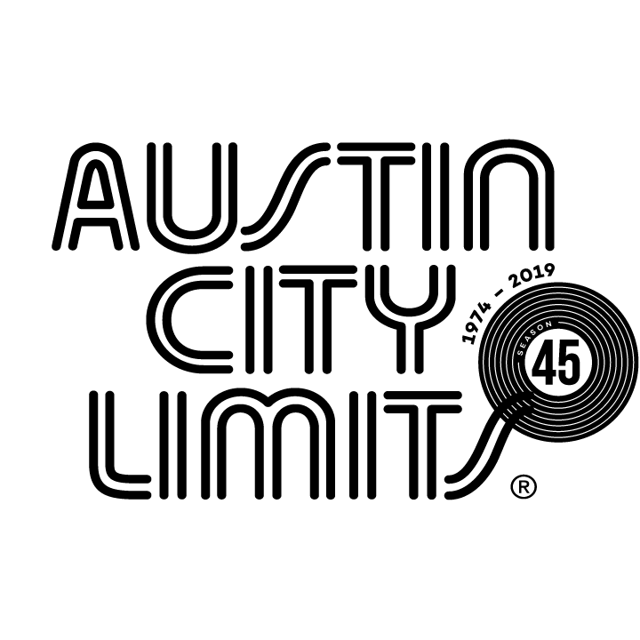

Gary Clark Jr. Leads Off New Season of Austin City Limits

Season 45 Premieres October 5 on PBS

Austin, TX—October 1, 2019—Austin City Limits (ACL) launches a new broadcast season of spectacular performances with a must-see hour taking a deep-dive with a boundary-pushing artist, Grammy® Award-winning Gary Clark Jr. The season premiere airs Saturday, October 5 at 8pm CT/9pm ET as part of ACL’s milestone Season 45. Providing viewers a front-row seat to the best in live performance for a remarkable 45 years, the program airs weekly on PBS stations nationwide (check local listings for times) and full episodes are made available online for a limited time at pbs.org/austincitylimits immediately following the initial broadcast. Viewers can visit acltv.com for news regarding future tapings, episode schedules and select live stream updates. The show's official hashtag is #acltv.

“Feels good up here,” proclaims Gary Clark Jr. during his third headline appearance on the ACL stage. The Austin native opens the hour with a blistering performance of the hit that launched his meteoric rise, “Bright Lights” from his 2012 debut Blak and Blu. The song’s refrain “...you gonna know my name,” couldn’t be more apt for the Texan who has had a whirlwind ascent from the Austin club scene to showstopping performances on festival stages around the world. Clark showcases songs from his latest, the critically-acclaimed This Land, his third major label release, which features some of his most powerful songwriting to date, with profound lyrics about life, love, restlessness and racism. Clark moves in and out of blues, soul, gospel, reggae and punk easily in the nine-song set, dazzling on the reggae-rock swagger of “Feelin’ Like A Million,” and shifting to the falsetto-laden “Feed the Babies”.

Bringing the crowd to their feet with a scorching rendition of his early classic “When My Train Pulls In,” Clark’s guitar solo is a masterclass in creative improvisation, wandering between different registers, exploring various motifs and bringing it down low to build it back into strobed-out fury. “I grew up watching ACL,” says the hometown hero who has stated he learned to play guitar watching his own heros, including Stevie Ray Vaughan, on old episodes of the series. Clark brings it all back to love, a frequent theme, with “Pearl Cadillac,” a gorgeous R&B/pop crooner dedicated to his mother and channeling another guitar hero, Prince. He closes out the explosive set with a fierce version of “This Land,” the socially-charged anthem and a personal battle cry. “Some times people don’t know how to act right, so I got something for them,” says Clark.

“It has been amazing and inspiring to see Gary grow as an artist since that first time he set foot on the ACL stage,” says longtime executive producer Terry Lickona. “From the first time I saw him play when he was 16, his talents were undeniable, and he has truly become the consummate artist – all the best that Austin represents.”

GARY CLARK JR. episode setlist:
BRIGHT LIGHTS
WHEN I'M GONE
I WALK ALONE
FEELIN' LIKE A MILLION
FEED THE BABIES
GOT TO GET UP
WHEN MY TRAIN PULLS IN
PEARL CADILLAC
THIS LAND

Season 45 Broadcast Line-up (seven new episodes to be announced):

October 5 Gary Clark Jr.
October 12 Maggie Rogers
October 19 Steve Earle & The Dukes: A Tribute to Guy Clark
October 26 H.E.R.
November 2 Patty Griffin / The Revivalists
November 9 Vampire Weekend
November 16 Kane Brown / Colter Wall
November 23 ACL Presents Americana 18th Annual Honors

The complete line-up for the full 14-week season, including seven new episodes to air beginning December 31, 2019, will be announced at a later date. Austin City Limits continues to offer its popular live streams of select performances for fans worldwide on ACL's YouTube Channel. Viewers can visit acltv.com for news regarding live streams, future tapings and episode schedules.

For images and episode information, visit Austin City Limits press room at http://acltv.com/press-room/.

About Austin City Limits
Austin City Limits (ACL) offers viewers unparalleled access to featured acts in an intimate setting that provides a platform for artists to deliver inspired, memorable, full-length performances. The program is taped live before a concert audience from The Moody Theater in downtown Austin. Austin City Limits is the longest-running music series in television history and remains the only TV series to ever be awarded the National Medal of Arts. Since its inception, the groundbreaking music series has become an institution that's helped secure Austin's reputation as the Live Music Capital of the World. The historic KLRU Studio 6A, home to 36 years of ACL concerts, has been designated an official Rock & Roll Hall of Fame Landmark. In 2011, ACL moved to the new venue ACL Live at The Moody Theater in downtown Austin. ACL received a rare institutional Peabody Award for excellence and outstanding achievement in 2012.

Austin City Limits is produced by KLRU-TV and funding is provided in part by Dell Technologies, American Airlines, the Austin Convention Center Department and Cirrus Logic. Additional funding is provided by the Friends of Austin City Limits. Learn more about Austin City Limits, programming and history at acltv.com.

