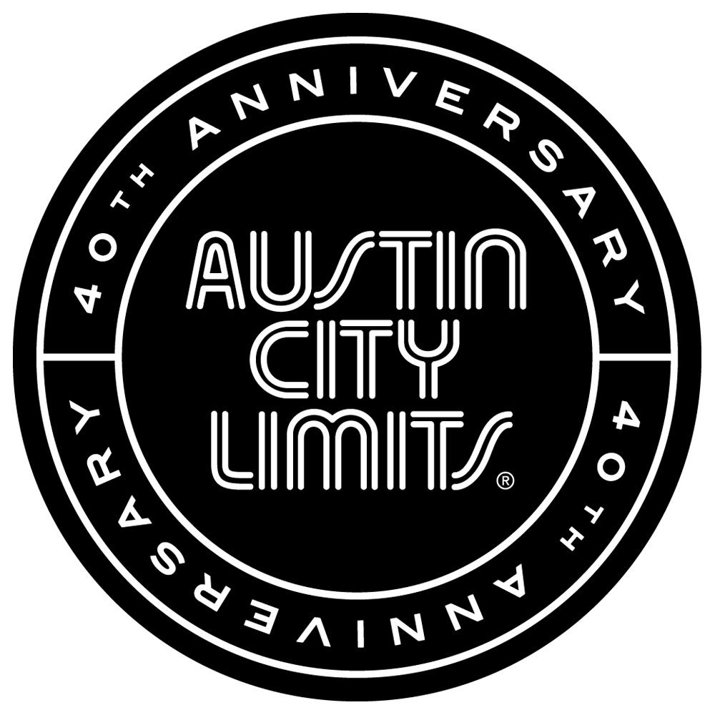

Austin City Limits Presents Great American Singer-Songwriters

New Episode Featuring Ryan Adams and Jenny Lewis Premieres January 24th

Austin, TX—January 23, 2015—Austin City Limits (ACL) continues its milestone Season 40 with an exceptional double bill: Ryan Adams paired with Jenny Lewis in a new installment showcasing the acclaimed singer-songwriters, both returning to the ACL stage for the first time in a decade for the landmark series 40th anniversary season. Frequent collaborators and recent tour mates, the LA-based artists perform separate sets and deliver knockout performances. The episode premieres January 24th at 8pm CT/9pm ET. ACL airs weekly on PBS stations nationwide (check local listings for times) and full episodes are made available online for a limited time at http://video.pbs.org/program/austin-city-limits/ immediately following the initial broadcast. The show's official hashtag is #acltv40.

A prolific songwriter with a 25-year body of work, Ryan Adams makes a memorable ACL return performing songs from his 2014 self-titled solo release. The album has generated critical accolades across the board and earned three 2015 Grammy Award nominations, including Best Rock Album. Hailed “one of the few truly great roots-rock troubadours left” by Entertainment Weekly, the North Carolina native tells the Austin crowd, ”We came here to play you really depressing music, but really loud.” Adams and his band the Shining launch into a career-spanning six-song ACL set with the bluesy rocker “Stay With Me,” on a stage outfitted with a vintage arcade video game, a stuffed tiger, an oversized fake amp and an American Flag customized with a peace sign. Adams moves seamlessly back and forth between new songs and long-time favorites in a must-see appearance, representing the impressive range of his storied career.

Indie-pop treasure Jenny Lewis returns for her solo ACL debut, nearly ten years since her debut on the program as frontwoman for the band Rilo Kiley. Lewis performs songs from her new album The Voyager, largely produced by Ryan Adams and widely regarded as one of 2014's best releases by Spin, Rolling Stone, TIME and many more. Rolling Stone raves, “Blending Laurel Canyon sensibilities with modern wit, The Voyager shows she’s stronger and wiser – and can still draw blood.” Decked out head-to-toe in her distinctive rainbow and stars suit (complete with matching guitar), she opens with the Rilo Kiley classic “Silver Lining” and continues with pop gems from her solo career including the recent singles “Just One of the Guys” and “She's Not Me”. Lewis closes out a sparkling set with her band mates surrounding a single mic for the beautiful, hymn-like “Acid Tongue,” “going full Joni Mitchell as she [sings] plaintively of liars, cobblers and sweethearts with the softest of hands” (Austin American-Statesman). After blowing a kiss to the audience, Lewis exits to wild applause, having captured the hearts of the Austin audience.

“The best songs are best sung by those who wrote them,” notes ACL executive producer Terry Lickona. “There aren’t many contemporary songwriters who are better than Ryan and Jenny, or singers who can bring their songs to life as well as they can. Theirs are the kinds of songs that will stay with you long after you hear them for the first time.”

Ryan Adams Setlist:
Stay With Me
Let It Ride
Do I Wait
Dear Chicago
When The Summer Ends
Shadows

Jenny Lewis Setlist:
Silver Lining
Head Under Water
Moneymaker
Just One of the Guys
She's Not Me
Acid Tongue

Season 40 | 2015 Broadcast Schedule
January 3, 2015 | The Avett Brothers / Nickel Creek
January 10, 2015 | Spoon / White Denim
January 17, 2015 | Sam Smith / Future Islands
January 24, 2015 | Ryan Adams / Jenny Lewis
January 31, 2015 | The Black Keys / J. Roddy Walston & The Business
February 7, 2015 | Foo Fighters
February 14, 2015 | Austin City Limits Hall of Fame Special

About Austin City Limits
ACL offers viewers unparalleled access to featured acts in an intimate setting that provides a platform for artists to deliver inspired, memorable, full-length performances. The program is taped live before a concert audience from The Moody Theater in downtown Austin. Austin City Limits is the longest-running music series in American television history and remains the only TV series to ever be awarded the National Medal of Arts. This year marks the 40th anniversary of the pilot episode taped in 1974 with Willie Nelson. Since its inception, the groundbreaking music series has become an institution that's helped secure Austin's reputation as the Live Music Capital of the World. The historic KLRU Studio 6A, home to 36 years of ACL concerts, has been designated an official Rock & Roll Hall of Fame Landmark. In 2011, ACL moved to the new venue ACL Live at The Moody Theater in downtown Austin. ACL received a rare institutional Peabody Award for excellence and outstanding achievement in 2012.

ACL is produced by KLRU-TV and funding is provided in part by Budweiser, the Austin Convention Center Department, Dell and HomeAway. Additional funding is provided by the Friends of Austin City Limits. Learn more about Austin City Limits, programming and history at acltv.com.

Media Contact:
Maureen Coakley for ACL
maureen@coakleypress.com
t: 917.601.1229

Maury Sullivan
KLRU-TV
msullivan@klru.org
t: 512.475.9087

