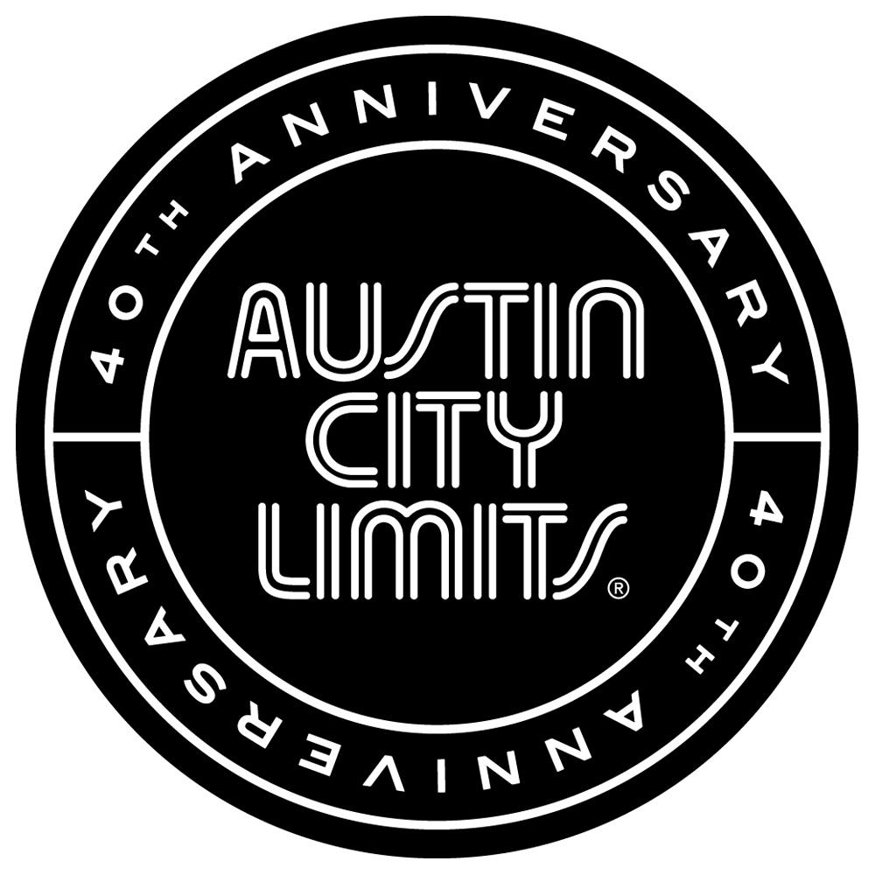

Austin City Limits Announces Season 40 Broadcast TV Schedule
Milestone Season Premieres October 4th with Beck

New Episodes Feature Ed Sheeran, Nick Cave & The Bad Seeds, Jeff Tweedy, Valerie June, Los Lobos, Eric Church & more

Austin, TX—August 12, 2014—The landmark television music series Austin City Limits (ACL) unveils its milestone 40th season, celebrating a four-decade run with more legendary artists, innovators and highly anticipated debuts. Providing viewers with a front-row seat to the best in music performance for 40 years, ACL returns on Saturday, October 4th with an unforgettable hour-long set from an American original, musician/songwriter Beck. Prior to the season premiere, a primetime special honoring the program's anniversary, Austin City Limits Celebrates 40 Years, airs Friday, October 3rd, 9-11pm ET on PBS Arts Fall Festival. ACL airs weekly on PBS stations nationwide (check local listings for times) and full episodes are made available online for a limited time at http://acltv.com/watch/ immediately following the initial broadcast. Select tapings are also live streamed to enable music fans everywhere to experience the performances as they happen, live and unedited. Viewers can visit acltv.com for news regarding future tapings, episode schedules and live stream updates. The show's official hashtag is #acltv.

Beck kicks off the celebratory season with an epic, career-spanning full-hour performance. One of the most creative artists of his generation, Beck shines in an exceptionally entertaining hour, showcasing a mix of vintage fan favorites and more recent gems. On the next installment, British sensation Ed Sheeran makes his ACL debut in a must-see episode that features the breakout star performing his entire set solo acoustic. Sheeran exudes the raw talent that propelled him to the top of the charts, with charged versions of hits from his landmark debut and new songs from the chart-topping follow-up release. Acclaimed Memphis singer-songwriter Valerie June shares the bill, making a captivating ACL debut with her starry-eyed roots music. Legendary industrial rock band Nine Inch Nails make a rare television appearance in an arena-worthy hour-long presentation that previewed in the spring to become one of ACL's most talked about episodes. A season highlight is the return of ACL veteran Jeff Tweedy for a special hour. The Wilco leader showcases his first-ever solo project Tweedy, performing a mix of new songs and Wilco classics joined by his son and special guests. Noir-rock outfit Nick Cave & The Bad Seeds make their ACL debut in a full-hour episode offering a memorable career-wide set powered by dark songs about love, death, God and fate. Music legends Los Lobos return to the ACL stage for their fifth appearance, with the influential and enduring East L.A. band celebrating their recent 40th anniversary alongside ACL’s.
The new season boasts a number of highly anticipated debuts from music innovators: Breakout country star Eric Church, folk-rock wonders Thao & The Get Down Stay Down and acclaimed southern rock band J. Roddy Walston & The Business.

ACL executive producer Terry Lickona says, “Anniversaries can seem trite and predictable, but this season is very special for me in so many ways. It represents 40 years of musical adventure and discovery. ACL fans have come to expect the unexpected, and we love it all. We celebrate our past, but we’re more excited about the future!”

For the fourth consecutive year, the producers of Austin City Limits, in conjunction with High 5 Productions, and the Americana Music Association, are proud to present a special ACL Presents—featuring the best music performances from this year's Americana Music Association Honors and Awards Ceremony held September 17th at the historic Ryman Auditorium in Nashville, TN.

Season 40 Fall Broadcast Schedule (additional episodes to be announced)

October 4 Beck
October 11 Ed Sheeran | Valerie June
October 18 Nine Inch Nails
October 25 Tweedy
November 1 Nick Cave & The Bad Seeds
November 8 Los Lobos | Thao & The Get Down Stay Down
November 15 Eric Church | J. Roddy Walston & The Business
November 22 ACL Presents: Americana Music Festival 2014

The complete line-up for the full 13-week season, including new episodes to air beginning January 2015, will be announced at a later date. Check the news section of acltv.com for additional episode updates.

ACL offers viewers unparalleled access to featured acts in an intimate setting that provides a platform for artists to deliver inspired, memorable, full-length performances. The program is taped live before a concert audience from The Moody Theater in downtown Austin. Austin City Limits is the longest-running music series in American television history and remains the only TV series to ever be awarded the National Medal of Arts. This year marks the 40th anniversary of the pilot episode taped in 1974 with Willie Nelson. Since its inception, the groundbreaking music series has become an institution that's helped secure Austin's reputation as the Live Music Capital of the World. The historic KLRU Studio 6A, home to 36 years of ACL concerts, has been designated an official Rock & Roll Hall of Fame Landmark. In 2011, ACL moved to the new venue ACL Live at The Moody Theater in downtown Austin. ACL received a rare institutional Peabody Award for excellence and outstanding achievement in 2012.

ACL is produced by KLRU-TV and funding is provided in part by Budweiser, the Austin Convention Center Department, Dell and HomeAway. Additional funding is provided by the Friends of Austin City Limits. Learn more about Austin City Limits, programming and history at acltv.com.

Media Contact:
Maureen Coakley for ACL
maureen@coakleypress.com
t: 917.601.1229

Maury Sullivan
KLRU-TV
msullivan@klru.org
t: 512.475.9087

