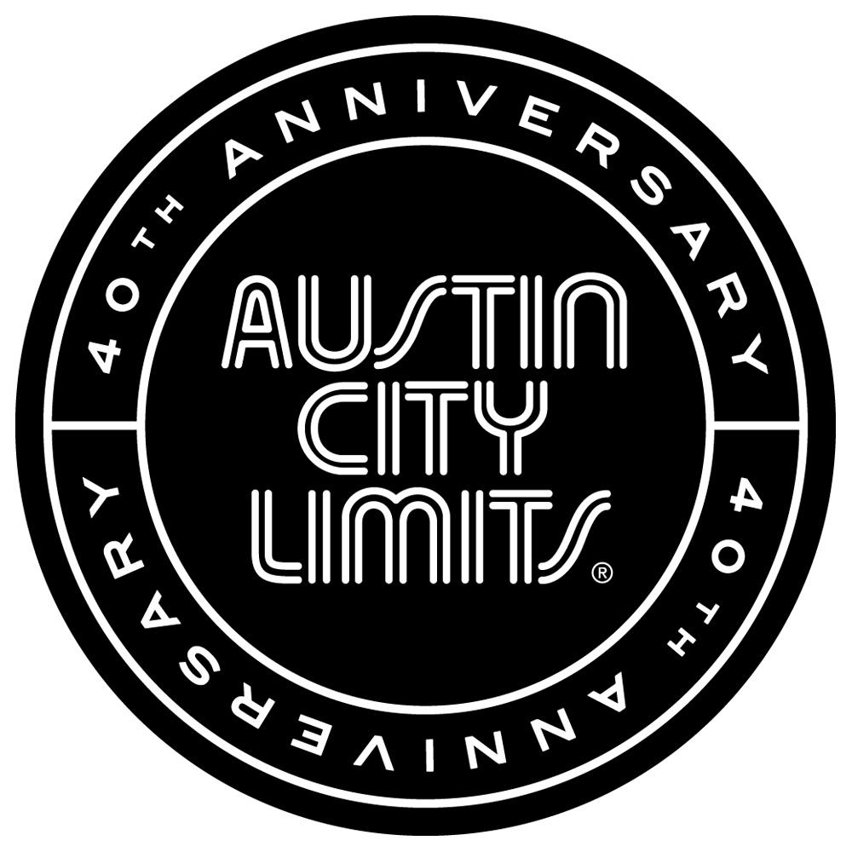

SOULFUL SOUNDS ON AUSTIN CITY LIMITS WITH SAM SMITH AND FUTURE ISLANDS

NEW EPISODE PREMIERES JANUARY 17th ON PBS

Austin, TX—January 16, 2015—Austin City Limits (ACL) presents an hour of soulful music from breakout sensations Sam Smith and Future Islands. The new episode, part of ACL's milestone Season 40, premieres Saturday, January 17th at 8pm CT/9pm ET. ACL airs weekly on PBS stations nationwide (check local listings for times) and full episodes are made available online for a limited time at http://video.pbs.org/program/austin-city-limits/ immediately following the initial broadcast. The show's official hashtag is #acltv40.

Chart-topping British soul singer and songwriter Sam Smith topped off a whirlwind 2014 with an astonishing six major Grammy and five Brit Award nominations. There is virtually no contemporary vocalist as stylish and elegant as Smith, a throwback to an elite crew of singers from an earlier era. A beautifully soulful singer, the 22-year old London native makes a stunning ACL debut performing the songs of unrequited love and heartbreak that drive his landmark platinum album In the Lonely Hour. Like soul singers of yore, Smith takes to the ACL stage as his eight-piece band is already laying into the show-opener “Nirvana,” the title track of his early EP. The vocal stunner pays tribute to one of his idols with an aching piano rendition of Whitney Houston's “How Will I Know”. Smith demonstrates his considerable range with an inspired mashup of his “Money On My Mind” fused with 90's club anthem “Finally”. Bringing the gorgeous set to a rapturous close with his signature song, the multi-platinum “Stay With Me”, Smith bares his soul with the Austin audience in the palm of his hand.

“Sam told me after the show that it was probably the best performance he’s given in America so far,” said ACL executive producer Terry Lickona. “This show deserves to be seen and heard by fans of great music and great singers everywhere!”

Baltimore's Future Islands share the episode, also making an epic ACL debut. Having steadily built a fan base since their first album in 2006, the synth-pop trio became a breakthrough smash in 2014 with the critically acclaimed Singles, landing on top of many year-end best lists including Pitchfork, Stereogum, Spin, Rolling Stone and NPR. Dynamic live shows featuring charismatic frontman Samuel T. Herring's hip-swiveling swagger and dramatic chest-beating have inspired their own internet memes. Spin raves “Calling on his Sam Cooke-meets-Tom Jones growl, Herring charges into every song, roaring with impassioned heart and soul.” As the band bound into their six-song set, Herring commands the ACL stage, delivering song after song of glistening pop while creating an emotional narrative of love, loss and inspiration. It's a transfixing debut, highlighted by a performance of their dazzling hit “Seasons (Waiting On You)”, crowned Song of the Year in the influential year-end Village Voice Pazz + Jop critics poll.

“I was mesmerized the first time I saw Sam Herring onstage, and booked him on the spot!” ACL executive producer Terry Lickona exclaimed. “In fact, I’ve never seen anybody put so much of himself into a performance. He’s like a man possessed!”

Sam Smith Setlist:
Nirvana
Together
How Will I Know
Money On My Mind/Finally
Stay With Me

Future Islands Setlist:
Back in the Tall Grass
A Dream of You and Me
Balance
A Song for Our Grandfathers
Seasons (Waiting on You)
Spirit

Season 40 | 2015 Broadcast Schedule

January 3, 2015 | The Avett Brothers / Nickel Creek
January 10, 2015 | Spoon / White Denim
January 17, 2015 | Sam Smith / Future Islands
January 24, 2015 | Ryan Adams / Jenny Lewis
January 31, 2015 | The Black Keys / J. Roddy Walston & The Business
February 7, 2015 | Foo Fighters
February 14, 2015 | Austin City Limits Hall of Fame Special

About Austin City Limits
ACL offers viewers unparalleled access to featured acts in an intimate setting that provides a platform for artists to deliver inspired, memorable, full-length performances. The program is taped live before a concert audience from The Moody Theater in downtown Austin. Austin City Limits is the longest-running music series in American television history and remains the only TV series to ever be awarded the National Medal of Arts. This year marks the 40th anniversary of the pilot episode taped in 1974 with Willie Nelson. Since its inception, the groundbreaking music series has become an institution that's helped secure Austin's reputation as the Live Music Capital of the World. The historic KLRU Studio 6A, home to 36 years of ACL concerts, has been designated an official Rock & Roll Hall of Fame Landmark. In 2011, ACL moved to the new venue ACL Live at The Moody Theater in downtown Austin. ACL received a rare institutional Peabody Award for excellence and outstanding achievement in 2012.

ACL is produced by KLRU-TV and funding is provided in part by Budweiser, the Austin Convention Center Department, Dell and HomeAway. Additional funding is provided by the Friends of Austin City Limits. Learn more about Austin City Limits, programming and history at acltv.com.

Media Contact:
Maureen Coakley for ACL
maureen@coakleypress.com
t: 917.601.1229

Maury Sullivan
KLRU-TV
msullivan@klru.org
t: 512.475.9087

