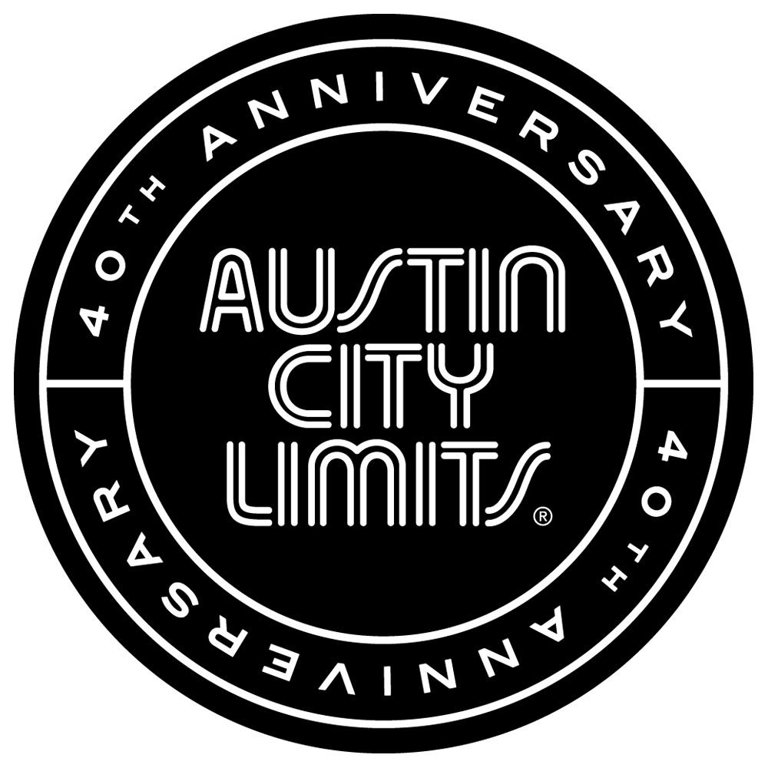

AUSTIN CITY LIMITS PRESENTS AMERICAN ORIGINALS:
LOS LOBOS AND THAO & THE GET DOWN STAY DOWN

New Episode Premieres November 8th on PBS

Austin, TX—November 7, 2014—Austin City Limits (ACL) presents true American originals—the legendary Los Lobos and folk rock wonders Thao & The Get Down Stay Down. Los Lobos return to the ACL stage for their fifth appearance, while innovator Thao Nguyen and her band The Get Down Stay Down make their ACL debut. Music mavericks with far-reaching influences, both acts exemplify ACL's outstanding legacy of “Great Music, No Limits.” The episode premieres Saturday, November 8th at 9pm ET/8pm CT as part of ACL's milestone Season 40. ACL airs weekly on PBS stations nationwide (check local listings for times) and full episodes are made available online for a limited time at http://video.pbs.org/program/austin-city-limits/ immediately following the initial broadcast. The show's official hashtag is #acltv40.

More than forty years into their run, Los Lobos are one of America's great rock 'n roll bands. The influential and enduring East L.A. band return to the ACL stage celebrating their recent 40th anniversary alongside ACL’s. “Los Lobos are still one of America's best, bravest, and most satisfying bands, and their skills and their instincts remain razor-sharp,” raves AllMusic. After four decades together the beloved band continue to create music that resonates with audiences around the world, and the three-time Grammy-winning group will be honored this year with a Lifetime Achievement Award by the Latin Recording Academy. Opening their ACL set with the fan favorite “La Pistola y el Corazon”, the group perform highlights from their vast catalog. The standout performance displays their world-class musicianship, as the veteran rockers perform their signature style of Chicano rock with an eclectic set of rock 'n roll, country, folk, R&B, blues and norteño music. The group close out the masterful set with “Mas y Mas”, joined by Austin's own Grupo Fantasma on horns, showing great music is universal.

"Los Lobos and ACL have always felt like kindred spirits," says ACL executive producer Terry Lickona. "We share the same impulse towards originality, experimentation and fun with music. They're still one of the best rock-and-roll bands in America!"

Led by enigmatic singer-songwriter Thao Nguyen, the San Francisco-based Thao & the Get Down Stay Down have built a devoted following based on their spirited live shows and their catalog of smart, genre-blending indie rock. The band’s ACL debut features them performing songs from their 2013 release We the Common. The group’s blend of rhythms and Thao’s folk-influenced fingerpicking give the band a distinctive sound that makes it stand out from the pack. Bandleader Thao’s natural exuberance and wide-ranging songwriting acumen make for a joyful, must-see ACL appearance. The band close out the scorching set with the singalong folk pop of “We the Common,” with the Austin crowd happy to oblige.

"Thao is a true artist for the 21st century,” says Lickona. “Her influences are wide-ranging, and her live performances are mesmerizing and infectious!"

Los Lobos Setlist:
La Pistola y el Corazon
Chuco's Cumbia
Little Things
Wicked Rain
Mas y Mas

Thao & The Get Down Stay Down Setlist:
The Clap/City
Know Better Learn Faster
Squareneck
Kindness Be Conceived
Every Body
We The Common

Season 40 Fall 2014 Broadcast Schedule (additional episodes to be announced)

October 4 Beck
October 11 Ed Sheeran | Valerie June
October 18 Nine Inch Nails
October 25 Tweedy
November 1 Nick Cave & The Bad Seeds
November 8 Los Lobos | Thao & The Get Down Stay Down
November 15 Eric Church
November 22 ACL Presents: Americana Music Festival 2014

The complete lineup for the full 13-week season, including new episodes to air beginning January 2015, will be announced at a later date. Check the news section of acltv.com for additional episode updates.

ABOUT AUSTIN CITY LIMITS:
Austin City Limits (ACL) is the longest-running music series in American television history and remains the only TV series to be awarded the National Medal of Arts. This year marks the 40th anniversary of the pilot episode taped in 1974 with Willie Nelson. Since its inception, the pioneering music series has become an institution that's helped secure Austin's reputation as the Live Music Capital of the World. The historic KLRU Studio 6A, home to 36 years of ACL concerts, has been designated an official Rock & Roll Hall of Fame Landmark. In 2011, ACL moved to the new venue ACL Live at The Moody Theater in downtown Austin. ACL received a rare institutional Peabody Award for excellence and outstanding achievement in 2012.

ACL is produced by KLRU-TV and funding is provided in part by Budweiser, the Austin Convention Center Department, Dell and HomeAway. Additional funding is provided by the Friends of Austin City Limits. Learn more about Austin City Limits, programming and history at acltv.com.

Media Contact:
Maureen Coakley for ACL
maureen@coakleypress.com
t: 917.601.1229

Maury Sullivan
KLRU-TV
msullivan@klru.org
t: 512.475.9087

