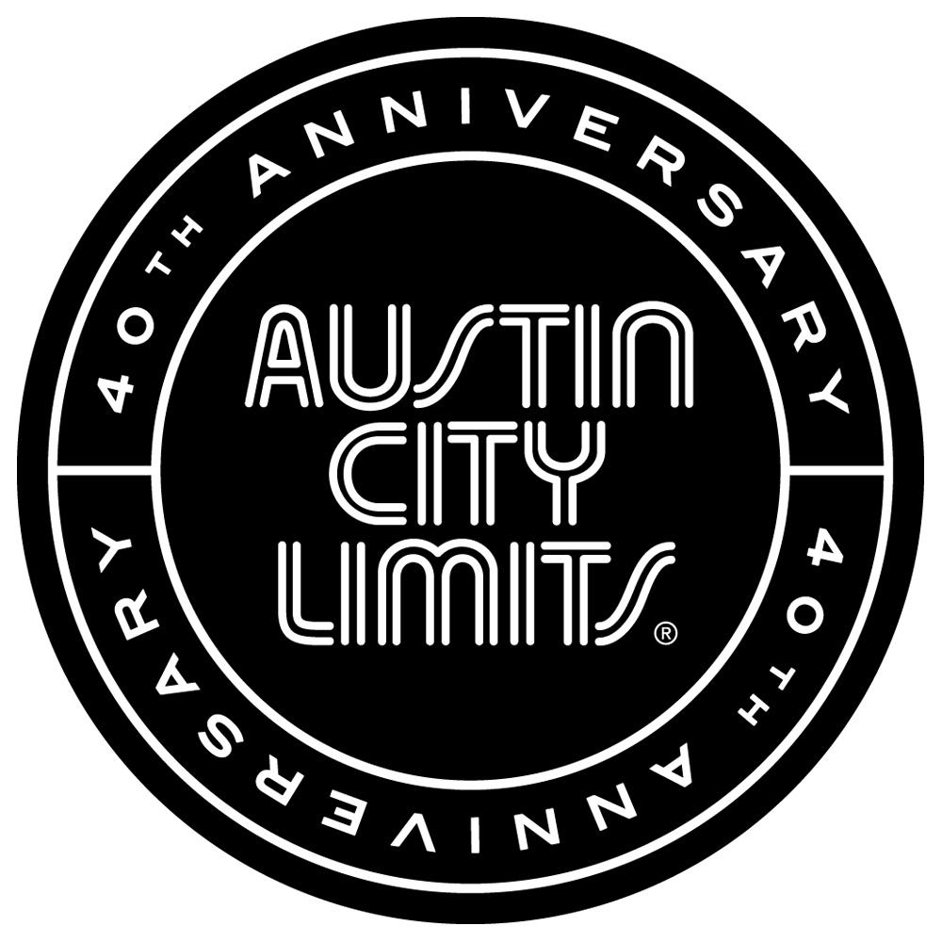

NICK CAVE & THE BAD SEEDS ELECTRIFYING AUSTIN CITY LIMITS DEBUT

New Episode Premieres November 1st on PBS

Austin, TX—October 31, 2014—Austin City Limits (ACL) presents an electrifying hour with Nick Cave & The Bad Seeds, one of the most exhilarating live acts in music. The noir-rock outfit make their ACL debut in an hourlong performance with a memorable career-wide set powered by dark songs of love, death, God and fate. The episode premieres Saturday, November 1st at 9pm ET/8pm CT as part of ACL's milestone Season 40. ACL airs weekly on PBS stations nationwide (check local listings for times) and full episodes are made available online for a limited time at http://video.pbs.org/program/austin-city-limits/ immediately following the initial broadcast. The show's official hashtag is #acltv40.

Nick Cave is one of contemporary music’s most powerful personalities, and the Australian-born iconoclast takes the ACL stage with his longtime band for an unforgettable appearance. The masterful nine-song set features highlights from their 30-year career, spanning the 1984 debut to 2013's universally-acclaimed Push the Sky Away, their fifteenth studio album.

The black-clad Cave stalks the ACL stage with primal energy and explores the thin line between light and darkness with selections from his fire-and-brimstone universe, spouting scripture-scaled narratives and anti-anthems from his rogue's gallery of characters. “Tupelo”, a twisted take on the mythos surrounding Elvis Presley, has the singer-songwriter ranting like an evangelist fallen from grace and intent on clawing his way back. Cave looks directly into the heart of darkness with a piano-based rendition of “The Mercy Seat”, a murderously powerful first-person account of execution by electric chair that progresses from the sinister to the sublime. The episode comes to a show-stopping end with the title track from their recent worldwide chart-topping release; as Cave sings the lyric “Some people say it's just rock 'n roll, ah, but it gets you right down to your soul”, the Austin crowd is rapt under his spell and ready to preach the gospel of Nick Cave.

“One of the most famous Austin City Limits episodes of all time was the Tom Waits show in 1978—people still talk about,” says ACL executive producer Terry Lickona. “Nick Cave is the Tom Waits show of the 21st century! You will absolutely tell your friends about this one. You’ve got to see it to believe it!”

Nick Cave & The Bad Seeds Episode Setlist:
Jubilee Street
Tupelo
Red Right Hand
Mermaids
From Her to Eternity
Love Letter
God Is In The House
The Mercy Seat
Push The Sky Away

Season 40 Fall 2014 Broadcast Schedule (additional episodes to be announced)

October 4 Beck
October 11 Ed Sheeran | Valerie June
October 18 Nine Inch Nails
October 25 Tweedy
November 1 Nick Cave & The Bad Seeds
November 8 Los Lobos | Thao & The Get Down Stay Down
November 15 Eric Church
November 22 ACL Presents: Americana Music Festival 2014

The complete lineup for the full 13-week season, including new episodes to air beginning January 2015, will be announced at a later date. Check the news section of acltv.com for additional episode updates.

ABOUT AUSTIN CITY LIMITS:
Austin City Limits (ACL) is the longest-running music series in American television history and remains the only TV series to be awarded the National Medal of Arts. This year marks the 40th anniversary of the pilot episode taped in 1974 with Willie Nelson. Since its inception, the pioneering music series has become an institution that's helped secure Austin's reputation as the Live Music Capital of the World. The historic KLRU Studio 6A, home to 36 years of ACL concerts, has been designated an official Rock & Roll Hall of Fame Landmark. In 2011, ACL moved to the new venue ACL Live at The Moody Theater in downtown Austin. ACL received a rare institutional Peabody Award for excellence and outstanding achievement in 2012.

ACL is produced by KLRU-TV and funding is provided in part by Budweiser, the Austin Convention Center Department, Dell and HomeAway. Additional funding is provided by the Friends of Austin City Limits. Learn more about Austin City Limits, programming and history at acltv.com.

Media Contact:
Maureen Coakley for ACL
maureen@coakleypress.com
t: 917.601.1229

Maury Sullivan
KLRU-TV
msullivan@klru.org
t: 512.475.9087

